SAP BASIS Training Topics | T-Code/Session | Child Session No. | Session No.
SAP | GUI |  | 1
SAP | HTML
System Monitoring |  |  | 2
 | SM50 | A
 | SM51 | B
 | ST03N | C
 | SM04 | D
 | SM12 | E
 | SM13 | F
 | SMGW | G
 | SP01 | H
 | SP02 | I
 | SP11 | J
 | SP12 | K
 | SM21 | L
 | SM36 | M
 | SM37 | N
 | ST02 | O
 | ST06 | P
 | System Status
client administration | SCC4 |  | 3
 | SCCL
 | SCC3
 | SCC9
 | SCC8
 | SCC7
 | SCC5
User Administration | SU01 |  | 4
 | SU10
Role and authorization | PFCG |  | 5
Change Document | SUIM |  | 6
TMS | STMS |  | 7
 | SE01
 | STMS_IMPORT
SAP ROUTER |  |  | 8
SAP Table | Se16
Start and stop SAP | Solman |  | 9
 | SAP App
DMS Server |  |  | 10
 | CSADMIN
 | SA38
 | RSHTTP80
DATA BASE Administration |  |  | 11
 | DB02
 | DB12
 | DB13
 | DBACOCKPIT
Service Market Place |  |  | 12
 | snote
Sap License administration | Slicense |  | 13
Support Patch administration |  |  | 14
 | SPAM
 | SAINT

SAP BASIS USER Training Document.
- SAP GUI: Graphical User Interface
There are three types of versions
- GUI for the Windows environment
- SAP GUI for the Java(TM) environment
- SAP GUI for HTML / Internet Transaction Server (ITS)

Now SAP fiori Apps is introduce so you can access through fiori APP.

How to Download & Install SAP GUI (Front End) for Windows
Before you can configure and use the SAP GUI, you need to download the software from the SAP Marketplace as per steps below –
Step 1) Goto support.sap.com to Download SAP GUI 7.40 for Windows
Step 2) Enter S-user and password as provided by SAP.
Step 3) Goto "Software Downloads."
Step 4) Choose "Browse our Download Catalog."
Step 5) Choose SAP Frontend components
Step 6) Choose SAP GUI for your OS. In this demo, we will select Windows-
Step 7) Choose SAP GUI 7.30 Core which is the latest one.
Step 9) Choose Add to download Basket
Step 10) Choose the Download Basket
Step 11) Choose Your download and it will begin.
URL support.sap.com
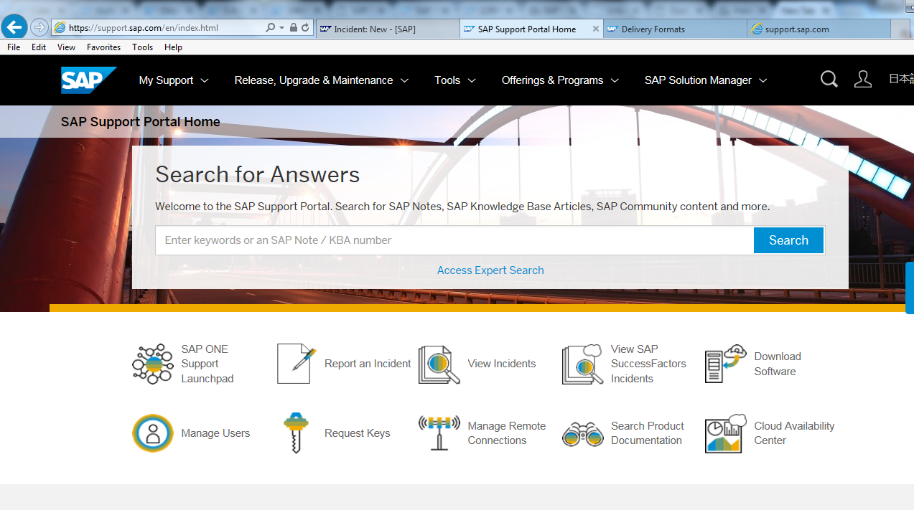
Click On Download Software
2
1
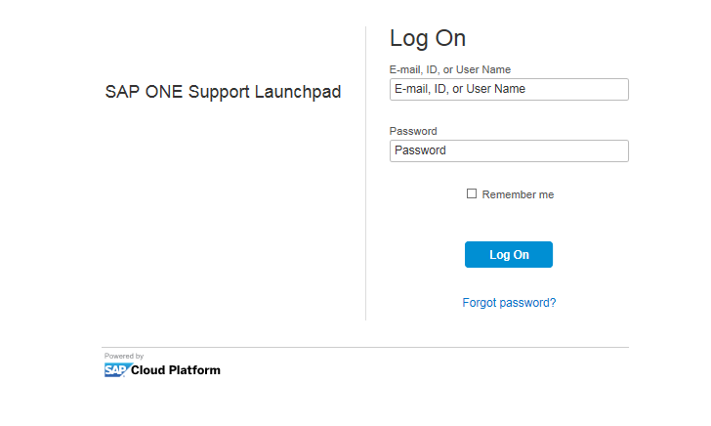
In above Screen enter (S-User ID) User Name and password and click on Login.
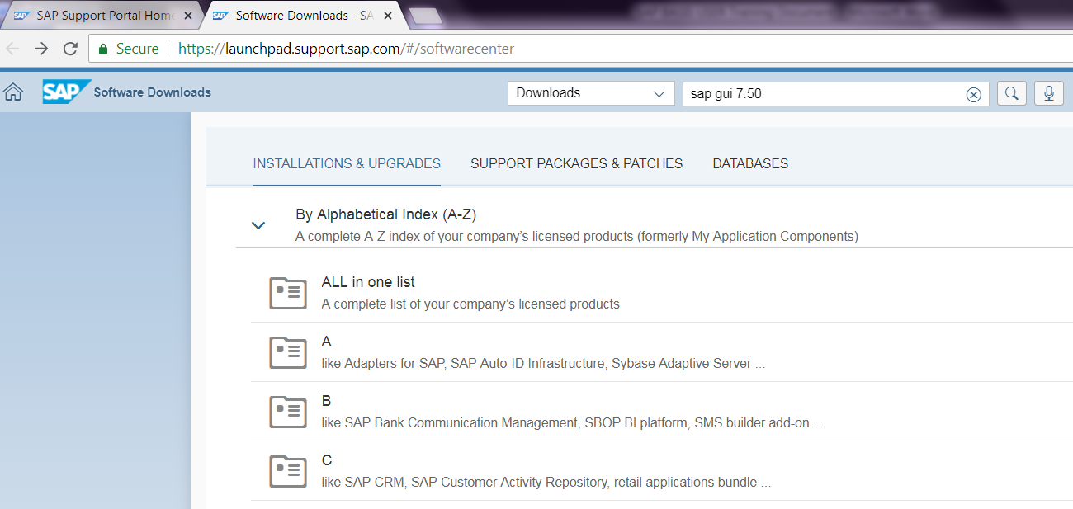
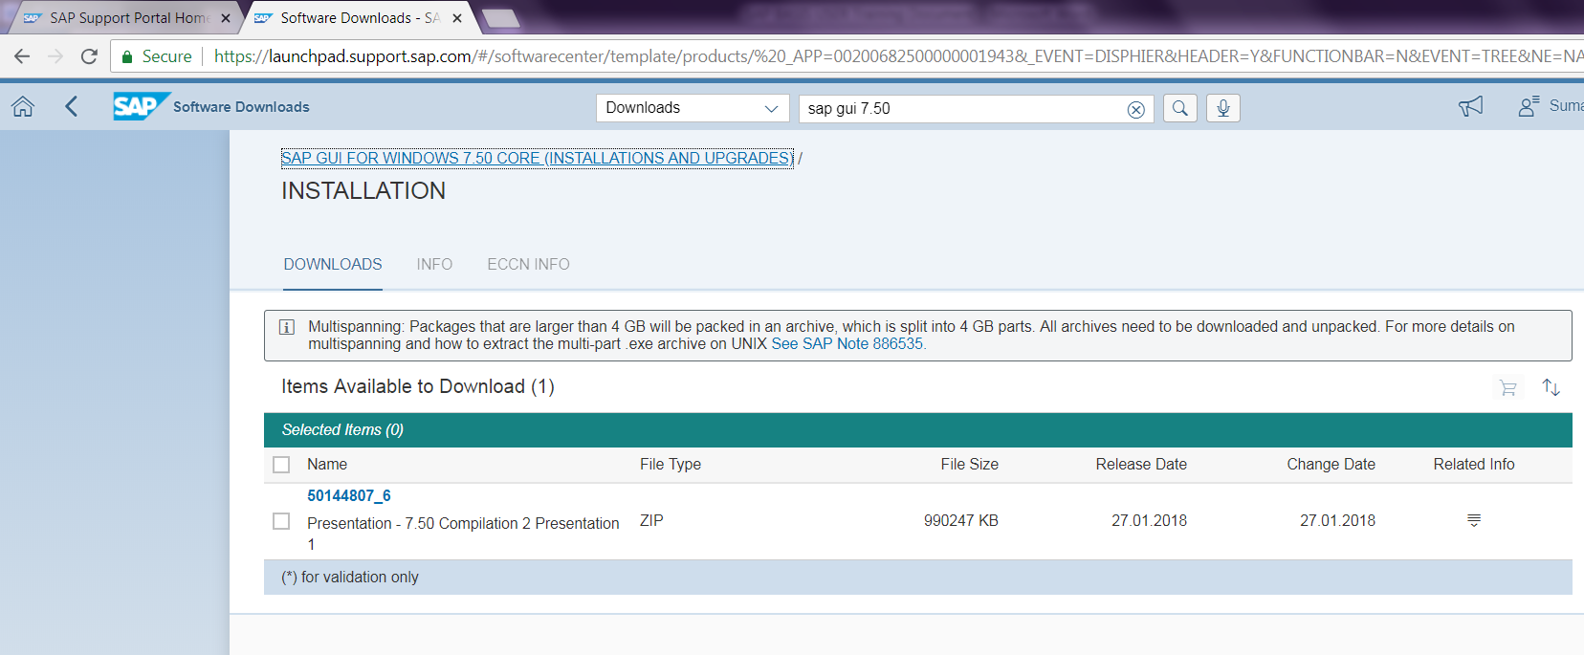

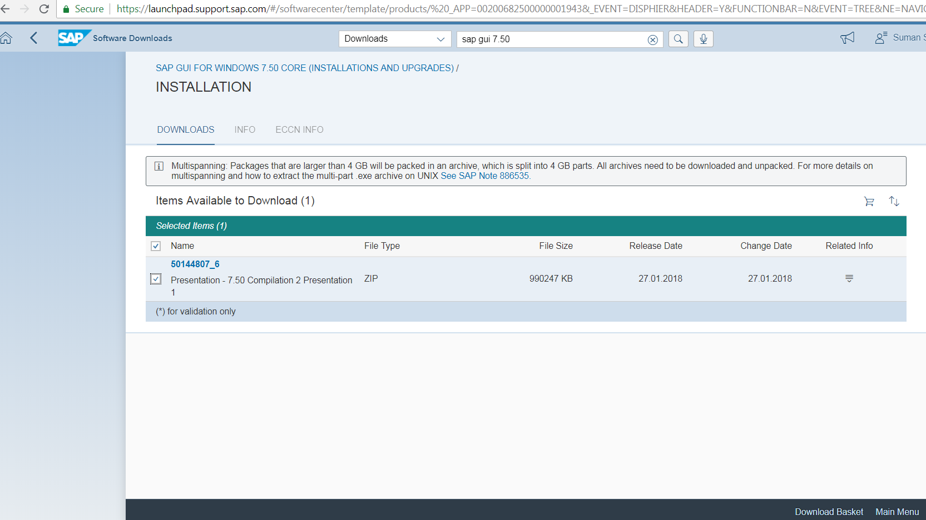

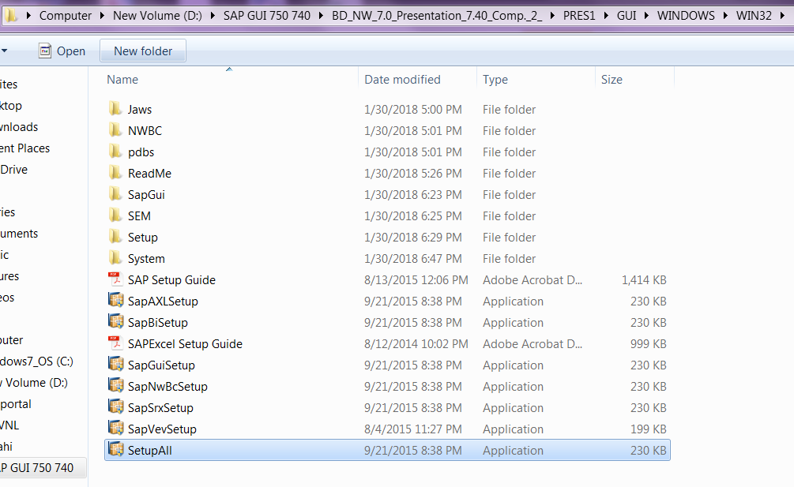
Double Click on SetupAll.exe
Browse the path for SetupAll.exe
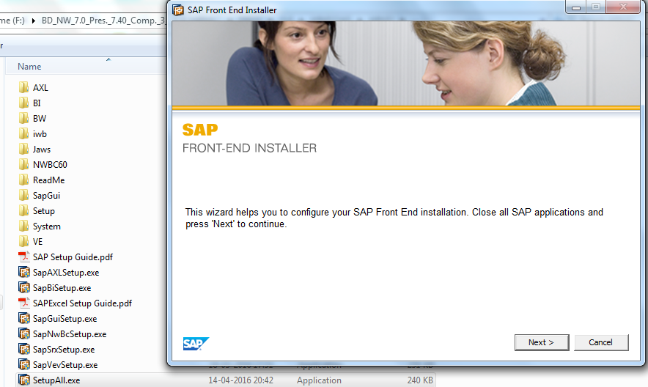
Click on Next
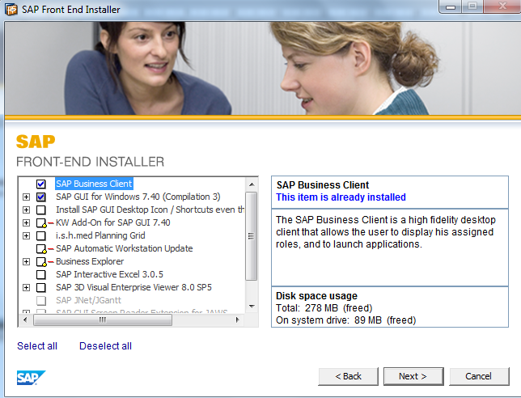
Select required options and Click on Next
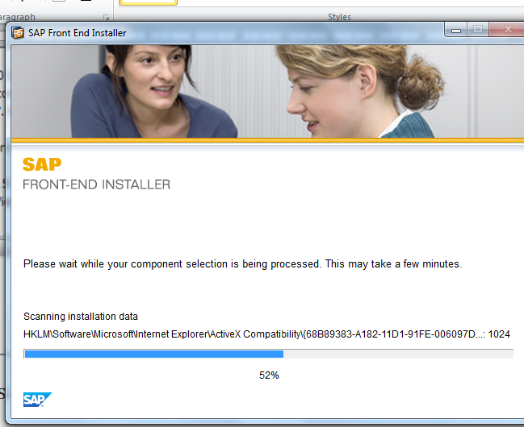
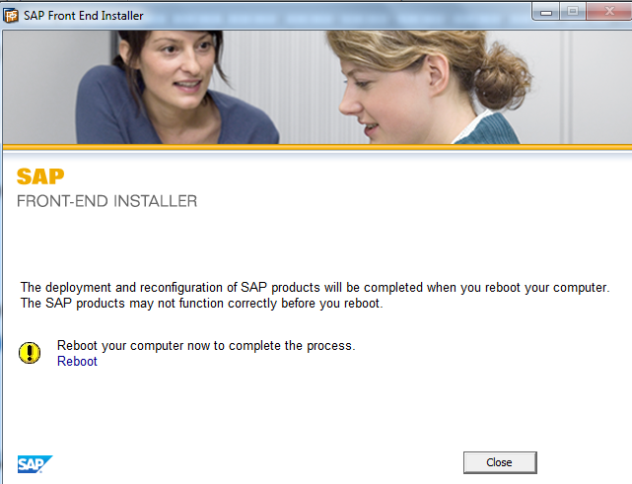
Finish

Time to configure your GUI
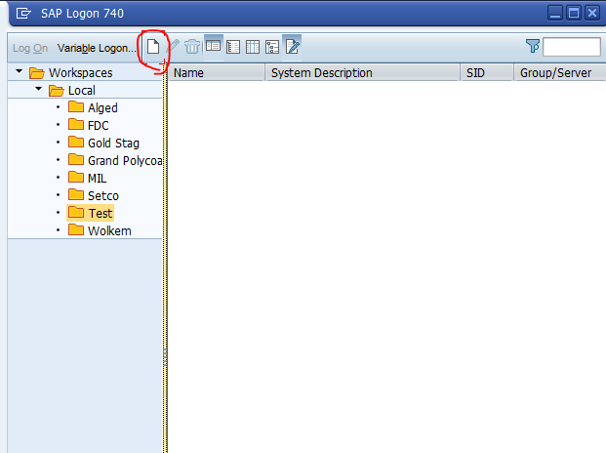

Click On New Connections
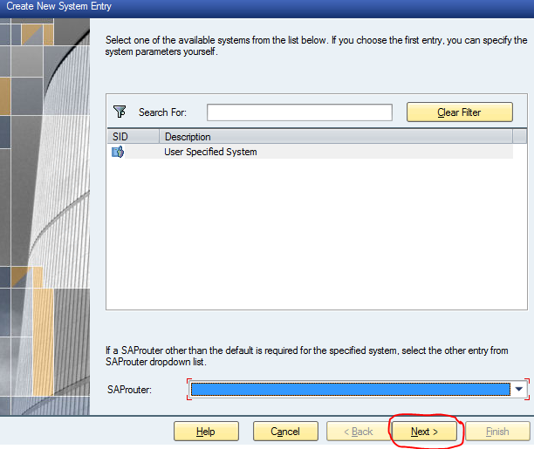

Click On Next
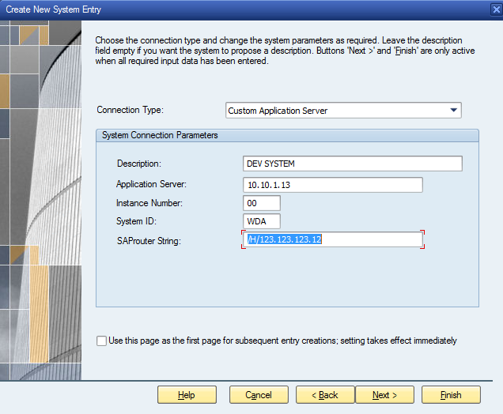
4) Provide router string if required
3) Enter System Instance Number
2) Enter application server IP
1) Enter Description
Then Click On Next.
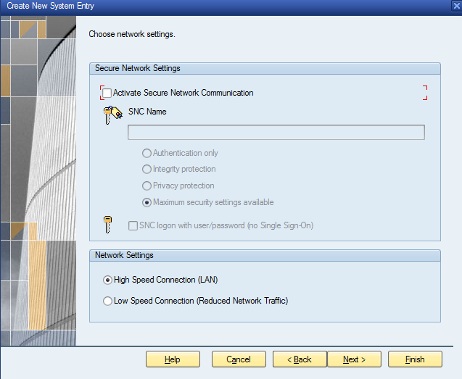
Select it if users are accessed through Remote locations
Select it if user available in LAN location
After All click on finish.
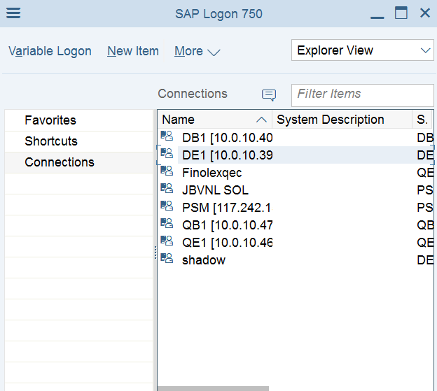
Double click on your connection
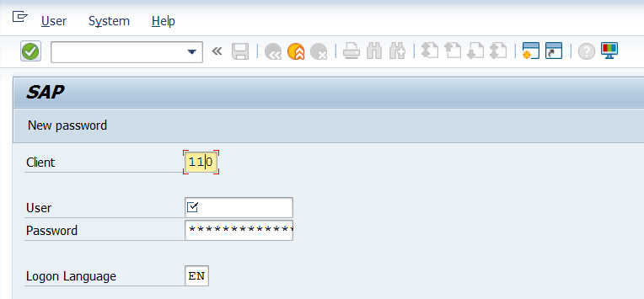
Now you can see you are able to access the system.
WEBGUI
In some cases users prefer to login to their SAP systems via the web. It could be because they travel a lot, or they do not have access to their computers all the time. In such cases SAP HTML can help them a lot.
This document describes how to configure SAP HTML on your SAP system:
1- Login to SAP system
2- Run t-code SICF to start activating the required services
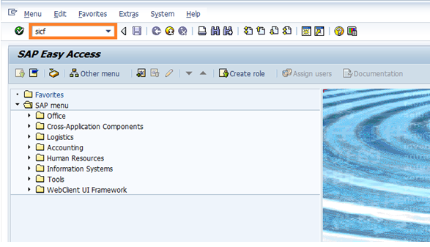
3- Click on execute

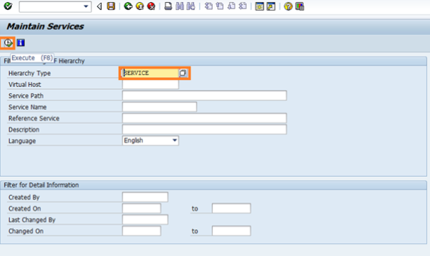
4- Navigate to /default_host/sap/bc/gui/sap/its/webgui and right click on to activate it
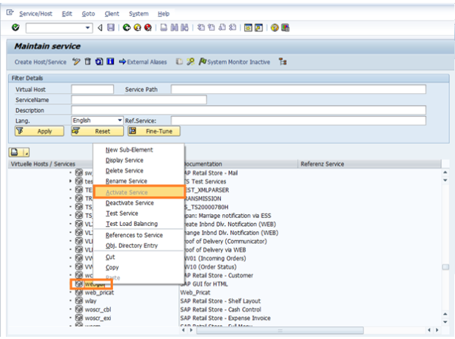
5- Double click on webgui service to make sure it is activated
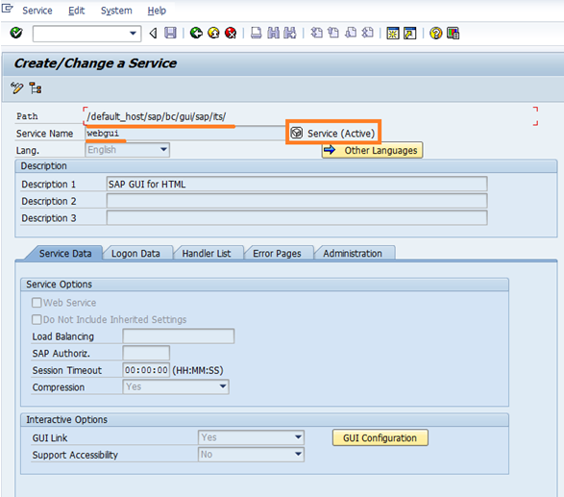
6- Navigate to the second required service /default_host/sap/public/bc/ur and right click on it to activate it
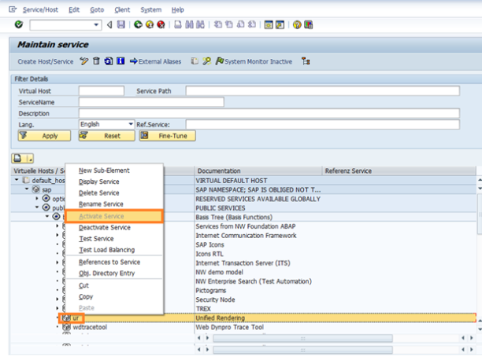
7- Double click on ur service to make sure it is activated
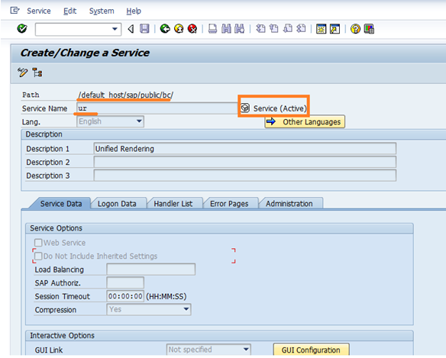
8- Navigate to the third required service /default_host/sap/public/bc/its/mimes
and right click on it to activate it
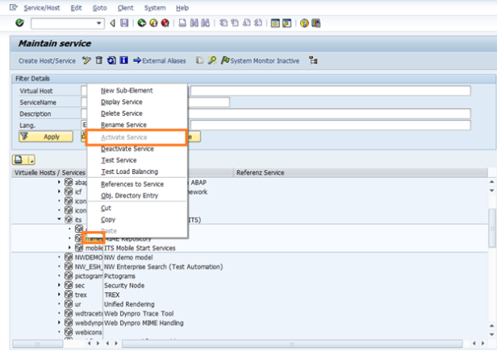
9- Double click on mimes service to make sure it is activated
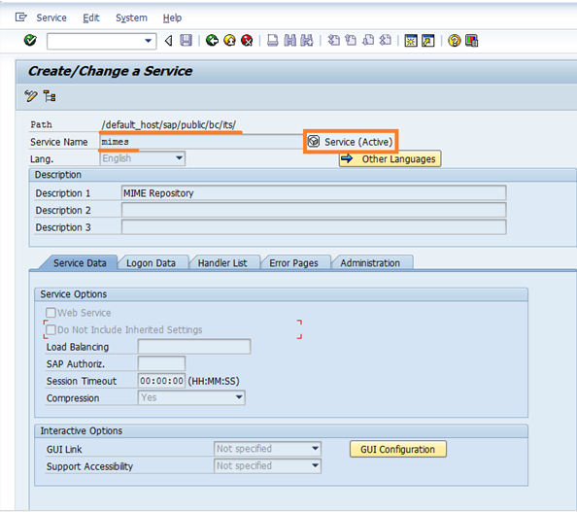
10- Run t-code SE80 to go to the ABAP Workbench
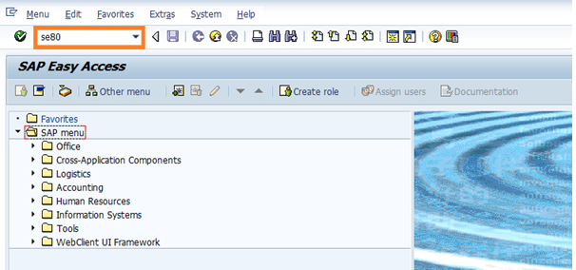
11- From the repository browser in your abap workbench from the dropdown list choose internet services
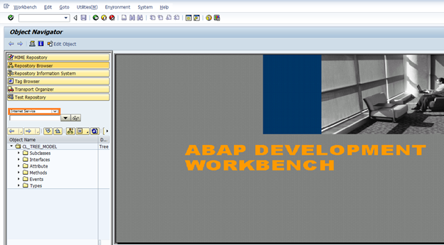
12- Type webgui in the field and press enter
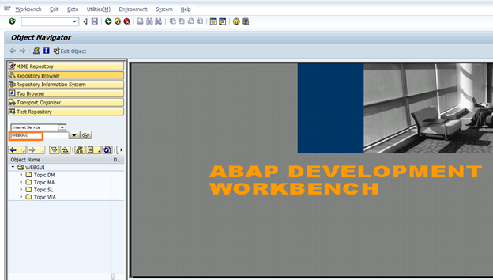
13- Give the value 1 to webgui parameter as the below:
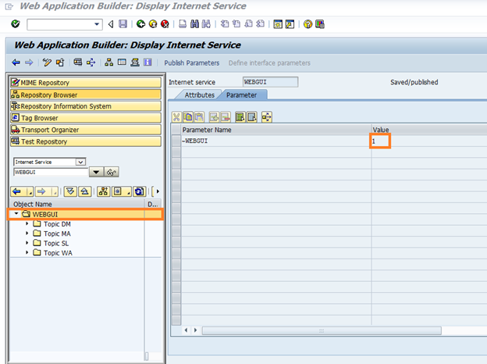
14- Save your changes
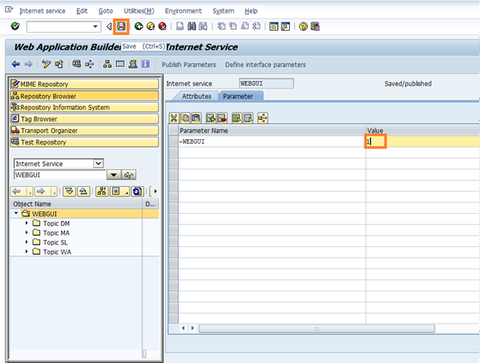
15- Go RZ10 and make sure that you have both parameters set, and if not then you need to define them:
login/accept_sso2_ticket = 1
login/create_sso2_ticket = 2
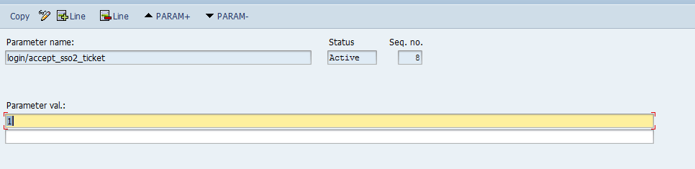
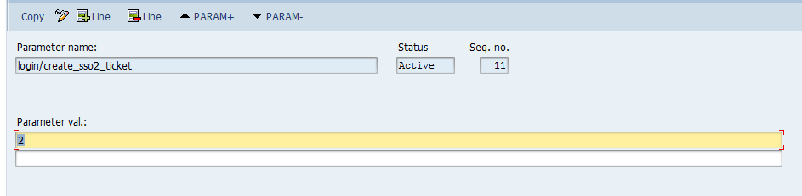
16- Run the t-code SIAC_PUBLISH_ALL_INTERNAL to start activating the services
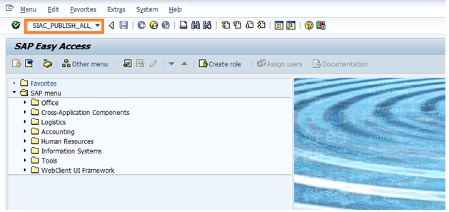
17- The activation will start as you will notice at the bottom of your screen
18- When the activation is done you should see a screen as the below mentioning that the activation was done successfully
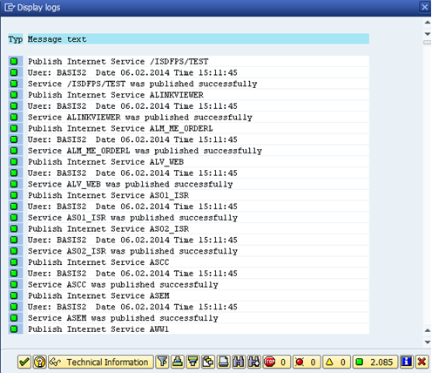
19- Now it is time to test what you did so far. To do that go to your browser and

run http://jbvnlsapde1.jbvnl.local:8000/sap/bc/gui/sap/its/webgui

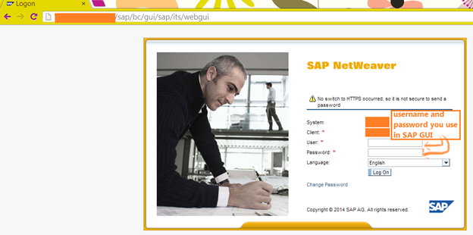

20- Your web page will look like the following:
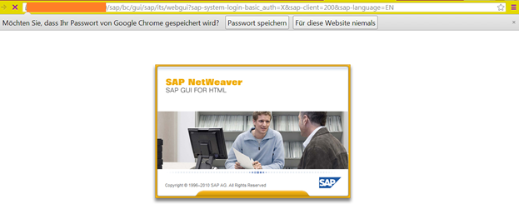

- SYSTEM Monitoring:
- SM50

Launch wok process monitor
Following is a part of SAP SM50 Work process overview screen which is showing status of all configured SAP work processes I manipulated the display to show all typical types of work process in an application instance Background(BGD), Dialog(DIA), Update(UPD & UP2).
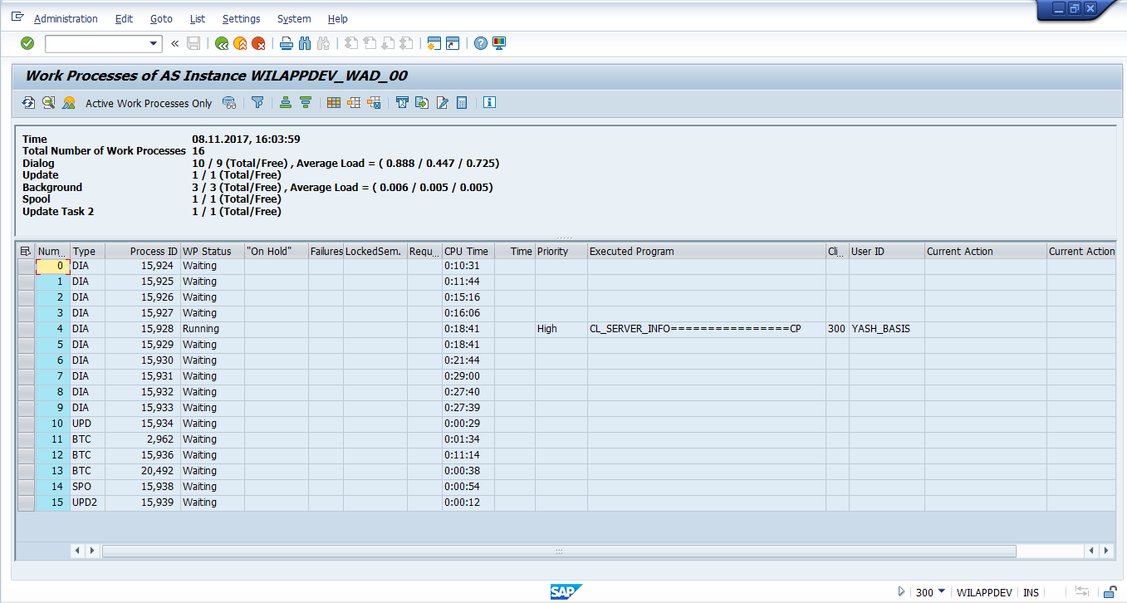
User who holding the process
Client
Activity
Priority
CPU Time
Process is running
Process is free and waiting for the operations
These are Background Process
3) This is Spool work Process
2) These are the UPDATE work process
1) These are the Dialog work process

SM50 Process Overview
Following is the Work process details screen which shows further information on a single work process
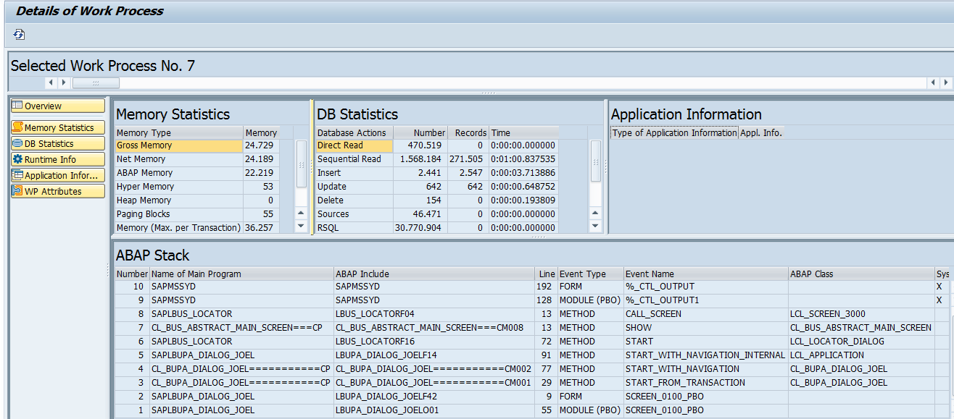
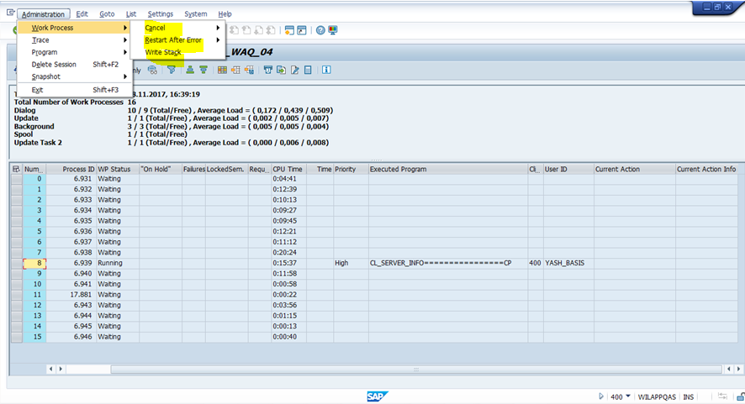
If you get any error in the process you can try above options after confirming with user
- SM51
Status

This field indicates the current status of a work process.

Waiting: Process is waiting for requests

Running: Process is processing a request

On Hold: Process is waiting for a message. Column Reason specifies what the work process is waiting for.

Stopped: Process was terminated because of an error

Shutdown: Process shut down

Reserviert: Process is reserved

Status

This field indicates the current status of a work process.

Waiting: Process is waiting for requests

Running: Process is processing a request

On Hold: Process is waiting for a message. Column Reason specifies what the work process is waiting for.

Stopped: Process was terminated because of an error

Shutdown: Process shut down

Reserviert: Process is reserved

Start

Restart work process after dump?

Indicates whether the terminated work process should be automatically restarted in by the dispatcher. The following values are possible:

Yes: The work process is restarted

No: The work process is not restarted (for example, if errors occur during the initialization phase).

You can set the work process by choosing Process -> Restart after Error -> Yes or No.

Err

Restart work process after dump?

Indicates whether the terminated work process should be automatically restarted in by the dispatcher. The following values are possible:

Yes: The work process is restarted

No: The work process is not restarted (for example, if errors occur during the initialization phase).

You can set the work process by choosing Process -> Restart After Error -> Yes or No.

Sem

Semaphore that the work process is waiting for

SAP number of the semaphore which blocks the work process:

If the field is green, the work process is holding the semaphore in question.

If the field is red, the work process waits for the semaphore in question.

The numbers stand for the following semaphores:

��1: PXA semaphore
��2: WP_CA_ADM semaphore
��3: APPC_CA_ADM semaphore
��4: TM_ADM semaphore
��5: COMM_ADM semaphore
��6: ROLL_ADM semaphore
��7: PAGING semaphore
��8: NO_BUFFER semaphore
��9: STAT semaphore
10: GW Request semaphore
11: CALI_BUFFER semaphore
12: TEMSE Char Code semaphore
13: Update-ADM semaphore
14: PRES_BUF semaphore
15: SHM_ADM_AREA semaphore
16: DB_TBUFF semaphore
17: DB_SYNC semaphore
18: DB_TTAB semaphore
19: DB_SNTAB semaphore
20: DB_IREC semaphore
21: DB_FTAB semaphore
22: LOGFILE semaphore
23: REQ_QUEUE semaphore
24: DB_TBUFF_P semaphore
25: ENQ_REQ semaphore
26: ENQ-TABLE semaphore
27: SAPCOMM_1 semaphore
28: SAPCOMM_2 semaphore
29: FIXADR semaphore
30: DB_CUA_BUFFER semaphore
31: Spool-ADM semaphore
32: Extended memory ADM semaphore
33: Extended segments semaphore
34: Server buffer semaphore
35: Object buffer semaphore
36: Extended segments user list semaphore
37: Global mutex semaphore
38: CCMS monitoring semaphore
39: Extended global memory semaphore
40: Semaphore reserved for testing
41: Semaphore reserved for testing
42: Shared statistic semaphore
43: Spool cache semaphore
44: Basis udit Semaphore
45: Application Statistic Buffer semaphore
46: Profile Parameter semaphore
47: Spool asynchronous RFC semaphore
48: ENQID semaphore
49: ABAP Virtual Machine Instruction Trace semaphore
50: Task handler runtime semaphore
51: ATRA semaphore
52: Memory pipes semaphore
53: Coverage Analyzer semaphore
54: ABAP Time Synchronization semaphore
55: Online Text Repository semaphore
56: ESM (Export to Shared Memory)- Semaphore
57: Runtime Monitor
58: JAVA
59: ABAP Shared Objects

60: JControl adminstration semaphore

61: JControl session semaphore
62: ITS plugin – update statistics
63: ITS plugin – service description

64: VM container lite cluster semaphore
65: Extended segments administration semaphore
66: VM Container adminstration semaphore
67: Extended memory adminstration semaphore
68: CCMS monitoring semaphore
69: Session breakpoint administration of ABAP debugger
70: Extended global memory adminstration semaphore
73: ABAP Hotspot Trace

I seldom observed a work process waiting for a semaphore.

CPU

CPU time
This is an accumulated CPU time consumed by all jobs and transactions executed under this process.

Time
Indicates the elapsed clock time used by a work process for the dialog step that is currently processing.
This time is reset with each commit statement or each screen change in online mode (Dialog step/transaction step)

Report
The report name that is currently being executed by the work process.
Exception: If the report name starts with ‘<‘and ends with ‘>’, then the work process does not execute an ABAP program but a kernel action.

- ST03N
To start SAP workload monitor, you can either use menu path or run SAP transaction ST03/ST03N directly. The initial screen of workload monitor is similar to what showed in Figure 1 normally.
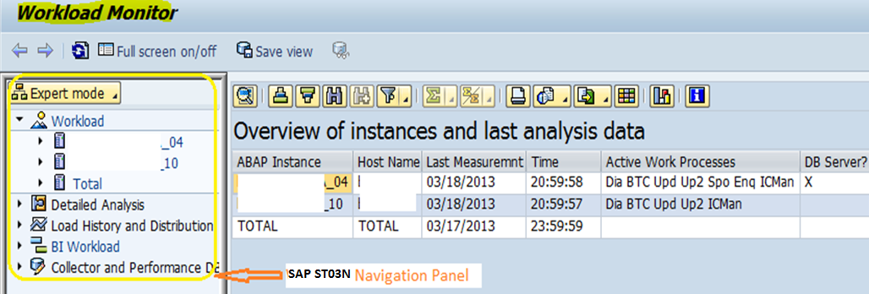
Figure 1 ST03 Initial screen – Navigation panel and Overview of instances

2. How to navigate through SAP ST03N workload monitor
You can navigate through SAP ST03N screens easily via built-in navigation planel showed in above Figure 1. On ST03N initial screen, you can access following functions:
- Workload – So you can analyze SAP historical workload for each uniqe combination of period, application-server or system, workload under this portion are aggregated,
- Detailed Analysis – So you can analyze SAP “current” workload data which can be drilled down to individual statistical record,
- Load history and Distribution – So you can compare and analyze performance overall several periods in one screen and
- Collector and performance database – this allows you to define retention period for different performance data collected. It also allow you to control what performance statistical data should be make available for SAP work load – business transaction analysis tool STAD.
Please refer to figure 2 for a brief description on navigation options. I would cover more details in following sections.
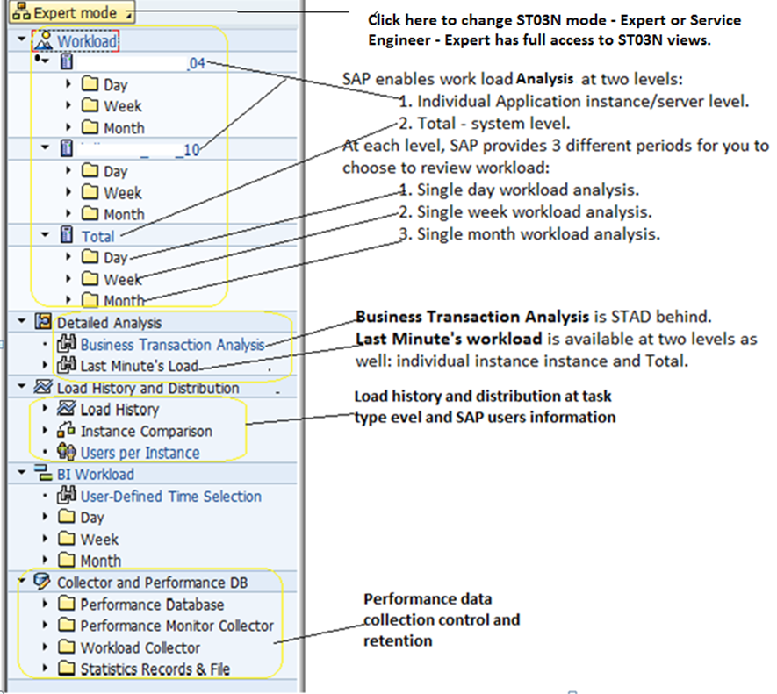
Figure 2 ST03N workload navigation option overview
Only entries starting with in ST03N represents an executable function. You need to click “” or “” icon to see ” entry” in navigation panel. To start a ST03N function via ST03N navigation panel, you need to double click on a entry like in Figure 2.

2.1 SAP Workload Review
ST03N organizes workload data into different views/profiles to facilitate performance analysis. Data in each workload view is organized into different tabs based on performance focus.
A workload view can be available for one period or one server/instance, but not available in another period or server when underlying data is not available. Data is not available due to two reasons: data is deleted and data has not been collected. You can make proper setting via ST03N or system parameter maintenance transaction RZ11 to control data collection and retention. For example, you do not see view in the lower portion of navigation panel showed in Figure 3. I would talk more in later portion of this post.

2.1.1 SAP workload overview screen
Data from SAP workload overview screen allows you to analyze SAP performance at system/server and task type level.
Now assuming that I need to review workload situation at system level (TOTAL) for a particular day, so I click the “Total” entry first, then “Day” entry, i double clicked the date –here June 17 2013, Screen similar to Figure 3 would show up.
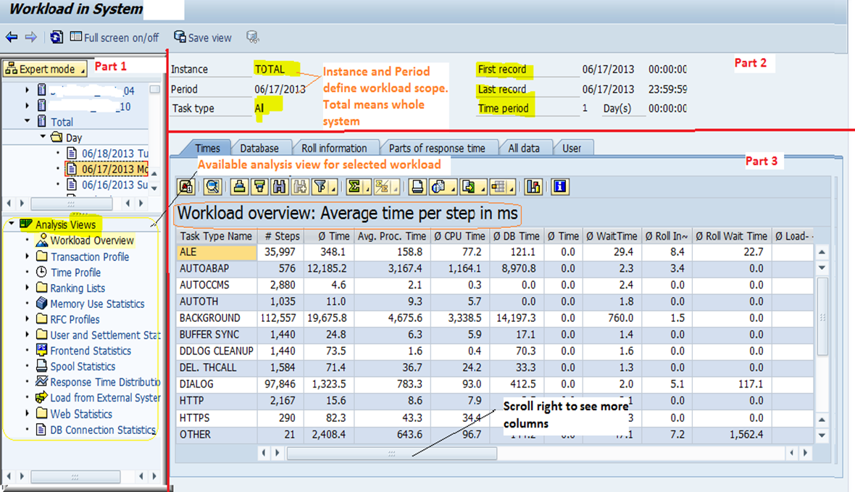
Figure 3 ST03N Workload Overview screen
Please note the main display has 3 components:
- Part 1 is navigation panel. Workload navigation panel has two portions – the upper portion is the ST03N transaction original navigation panel, the lower portion shows a list of available analysis views for SAP workload analysis.
- Part 2 is workload header information – showing period (a customer period, a day, a week or a month) where workload is related, instance (a specific instance or total) and task type (a specific task type or all). Please double check with 1st records and last records and time period field to ensure that you got all workload from the period you selected.
- Part 3 is workload details.

Workload over view screen is the initial view presented by ST03N for load analysis. The workload overview shows times statistics consolidated according to SAP task types. In a SAP ECC system, Dialog, Background, RFC, ALE and Updating task performance are most critical to business function. Workload overview screen provides a performance overview on task type level.

There are several tabs in Workload overview to help you to quickly locate the data you might need. The user tab shows number of accumulated users from the system/instance for the selected period.

In the left bottom corner of Figure 3 is a list of analysis views available for the workload in the selected period and server scope. You can navigate to any view by moving your cursor and double clicking the view like “standard” under “Transaction Profile”.

2.1.2 ST03N Transaction profile
Data from transaction profile allows you to do application performance analysis.
There are two versions of transaction profile – one is “Standard”, the other is “EarlyWatch”. Standard profile has more navigation feature and provides workload breakdown based on SAP task types.
Double click “Standard” under “transaction Profile”, You would get screen similar to figure 4
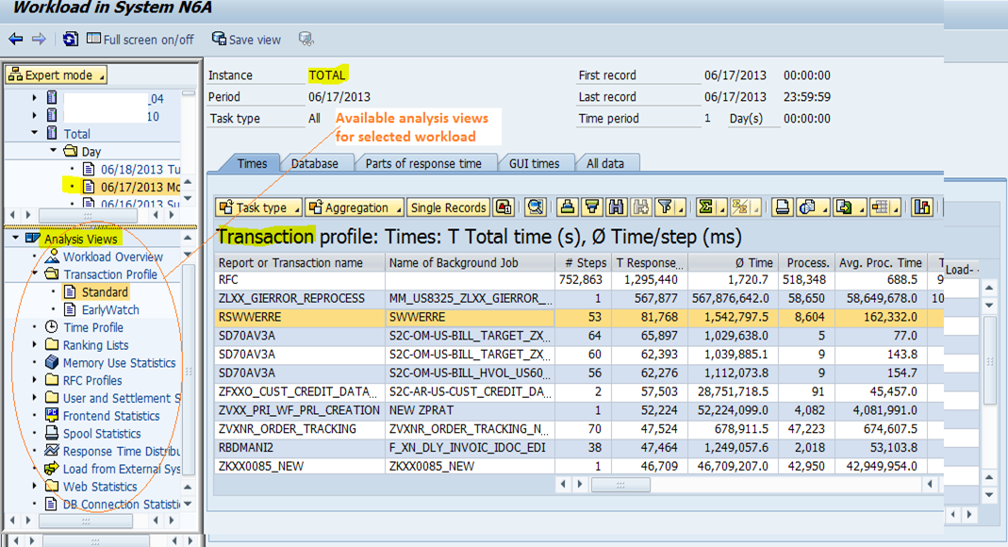
Figure 4 SAP workload – standard transaction profile
In figure 4, “All data” tab is organized into several child tabs – Times, Database, Parts of response time, GUI times with default tab “Times” displayed. GUI Times tab is only applicable to Dialog type task.
EarlyWatch transaction profile is similar to “standard” transaction profile. The difference between them is that EarlyWatch consolidates workload displayed in Figure 4 based on the 1st column – “Report or Transaction name”. This helps if you want to know top load programs in the system.
Table 1 – Workload view navigation buttons
Your goal | Button should be clicked | Comment
Filter display by task type |  | You select corresponding “task type” from the pull-down menu which has “Dialog”, “BACKGROUND”, “RFC” and etc. You can select “Dialog” task type so only online executed transactions are displayed.
Aggregate workload |  | This allows you to aggregate workload on one of SAP predefined levels: Application such as CO, LE, MM, FI and etc, Subapplication like MM-IM, MM-PUR etc , package and transaction. Default level is transaction.
Check individual statistical records |  | To use this, you need to place cursor on selected row first. This works only with “current data” while STAD works. Current data is normally referring to data related to transaction executed in recent 48 hours.
Check Column full name |  | Long-short name to give you more meaning of the column or save the column width.
Filter display by column |  | Filter display based on column like Disk reads, Program name etc. You can click a column first or you can select columns for sorting from available fields after you click the filter button.
Sort display |  | Sort in Ascending or Descending in expected column. Click the column name first before the sort button is clicked.
Search on the screen |  | You can search the display based on specific value from any column.
Summarize numeric column |  | You need to select the numeric column like “# steps”, then click this button
Export the display to a local file |  | Save displayed workload data to local file.
Chang display |  | You can control what column should be displayed and their position and save it for future use.

The same button has the same usage regardless of ST03N analyst views you are working with although some buttons are only applicable to specific views like “single records” button which is not available in workload default view – workload overview.

2.1.2 ST03N time profile
Data from ST03N time profile view allows you to analyse performance/load difference between different hours.
Double click “Time Profile” entry in navigation panel (see Figure 3), you would see screen similar to figure 5.
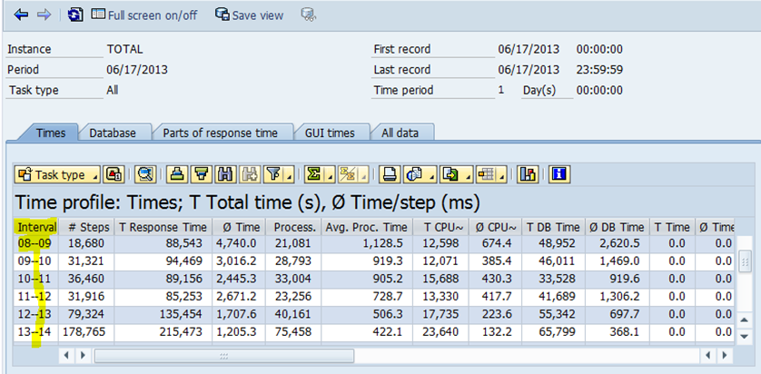
Figure 5 ST03N SAP workload time profile
Time profile separates workload from a period ( a day, a week or a month) into hourly fashion. So you can know the busiest hours in terms of workload.
If your display is not in hourly fashion, you might need to refer to following ossnote :
- 17750 workload: time profile also for night hours and
- 910897 ST03N: Configuration of time profile.

2.1.3 ST03N RFC Profiles – RFC Server profile
Data from ST03n RFC profiles allows you to analyse RFC performance.
You can use ST03N to review RFC workload. RFC workload is further separated into RFC client profile, RFC server profile, RFC Client Destination and RFC Server Destination profile. This makes it easier for you to do specific workload analysis.
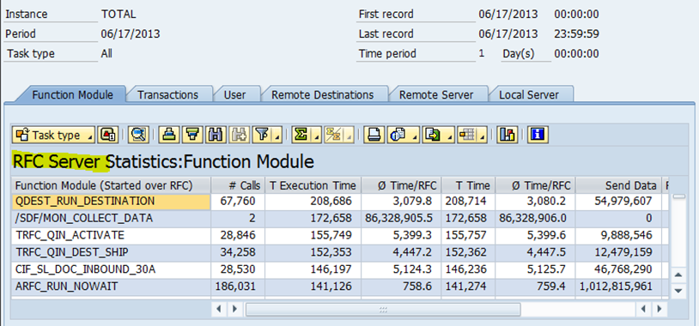
Figure 6 ST03N – RFC Server profile
RFC Server Destination profile
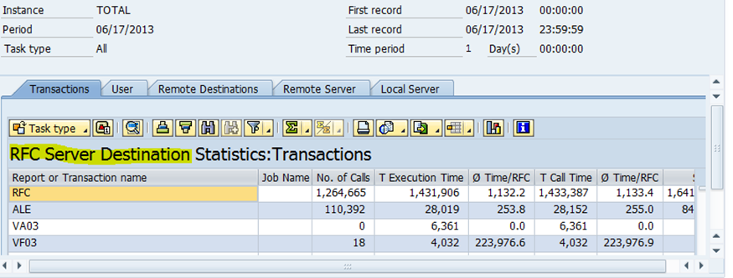
Figure 7 ST03N – Destination profile

2.1.4 SAP ST03N Response Time Distribution view
Data from this view can allow you to see transaction step distribution based on duration.
Double click “Response Time Distribution” entry in workload navigation panel, you would get screen like Figure -8.
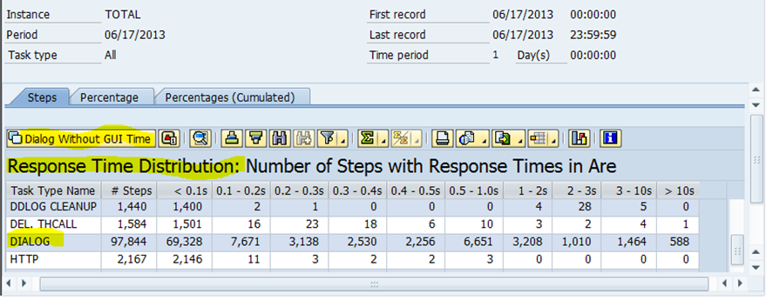
Figure 8 ST03N Response Time Distribution
Number of dialog steps under 1 second is often used to measure a system performance based on % of dialog response time under 1 seconds.

2.1.5 SAP ST03N – other workload analysis views
You can navigate to other workload analysis views like Memory Use Statistics, Ranking lists, User and Settlement Stat etc in the same fashion. You might need to review those views based on specific situation – for example, if you would like to tune memory usage and need to identify top memory consumer, ST03N Workload – Memory Use Statistics view is a good place to start.

2.2 Detailed Analysis
Here, you can analyze “current” workload which might not show up in workload analysis we have covered in previous section of this post, you can access individual SAP statistical record via button showed in figure 4.

2.2.1 Business Transaction Analysis
Click this entry, it would start SAP STAD transaction giving you access to recent individual performance statistical records. You can refer to my post on how to run SAP STAD transaction.

2.2.2 Last Minute’s load
To see last minute’s workload, you need to click a server or total( whole system) , input the data and then hit the execution or continue key. Please refer to Figure 6 with input data.
“Time profile granularity” might be helpful for you to organize workload data into “good” period and “bad” period for easy comparison in performance analysis.
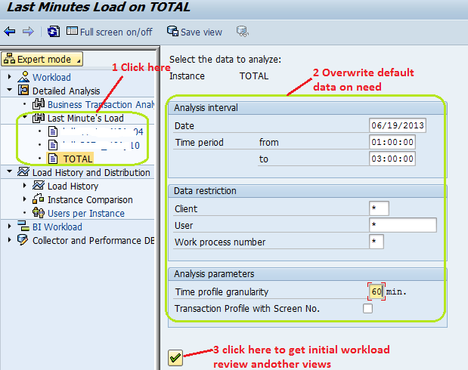
Figure 9 ST03N last minute’s Load initial screen
After you enter your data and hit execution, you would get all normal views we covered in “workload” section of this posts and you can access those workload views in the same way which is covered in workload section of this post.
When I hit “OK” or continue button in figure 6, I got a “workload” overview screen normally. However I presented ” time profile” view of workload in Figure 7 as an example.
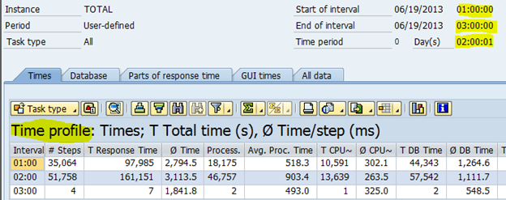
Figure 10 ST03N last minute’s load – time profile
Each time you run SAP ST03N to review workload for selected server/instance, the default view would be workload overview. However if you would like to review workload in another server etc., the default view is the last analysis view you review with previous workload analysis.

2.3 Workload History and Distribution
In this section, three analysis options are available
- Load history,
- Instance Comparison and
- Users per Instance.
You use navigation panel to access those analysis option by clicking corresponding leaf entry.

2.3.1 ST03N Load History
Data from load history view allows you to analyze performance trend of a SAP system/application/task types.
You can review workload history of single instance/server or workload history of whole system. If you double click on “total” entry, you would get workload history screen similar to Figure 8.
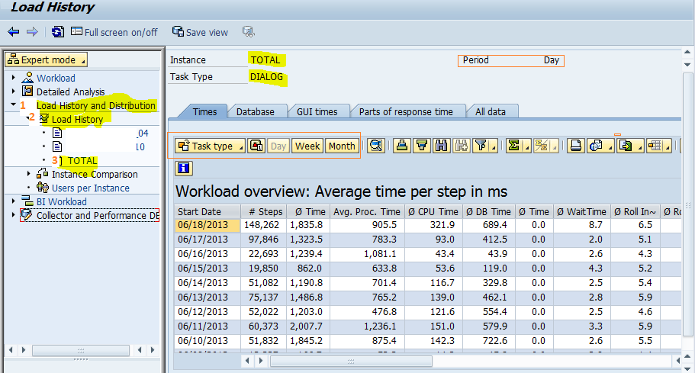
Figure 11 ST03N workload history at system level
Click button “Task type” in figure 11, you can review workload for the expected workload type. Click Week and Month button in Figure 11, Number of steps would be summarized and response time would be averaged in expected time interval.

2.3.2 Instance Comparison
Data from instance comparison allows you to analyze performance among different instances.
Workload data in different application server can be compared in day, week and month interval. Please refer to figure 12 for navigation path.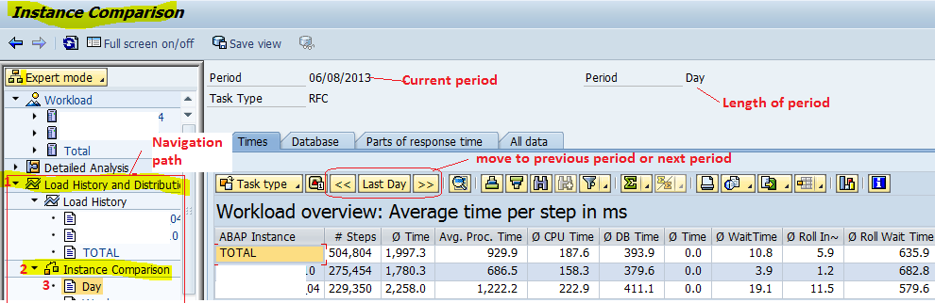
Figure 12 ST03N Instance comparison

2.3.3 Users per Instance
Double click “User per Instance” under path “ST03N -> Load History and Distribution”, you would see screen similar to Figure 13.
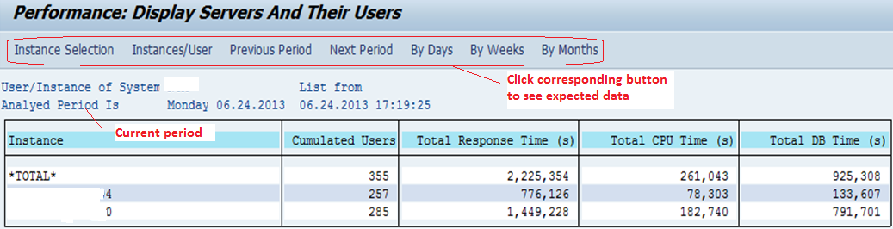
Figure 13 ST03N Users per instance

2.4 Collector and performance DB
Here, SAP ST03N allows you to define retention period for data used in SAP ST03N. It also allows you to have control over some online parameters which control statistical sub-record generation or collections temporarily. Those online parameter changes could be lost or replaced by the value from sever/instance profile. Please refer to Figure 14 for function details

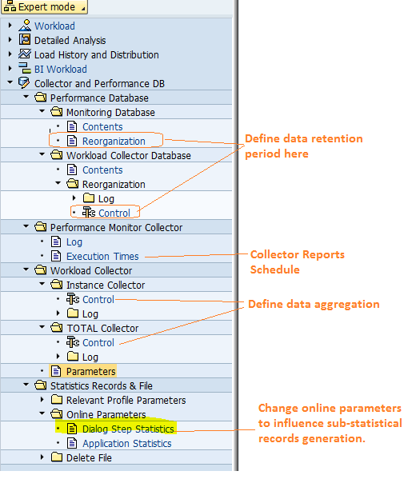

2.4.1 Define data and workload review retention period
Double click on “Reorganization” under path “SAP ST03N -> Collector and Performance DB -> Performance Database ->Monitoring Database”, you would see screen similar to
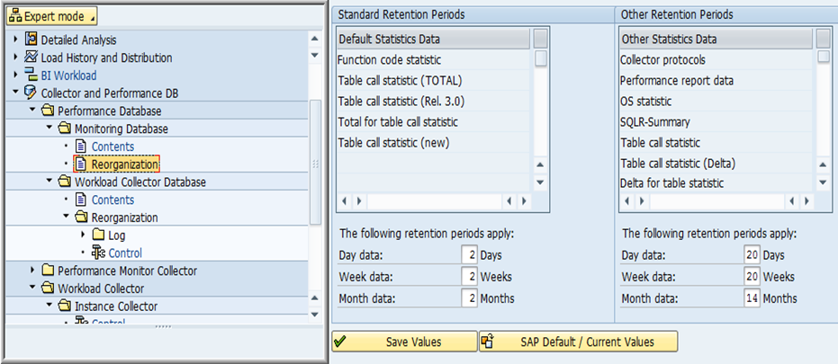
Figure 15 Performance database retention period
You can overwrite the number based on your specific need.
Double click on “Control” under path “ST03N -> Collector and Performance DB -> Performance Database -> Workload Collector Database -> Reorganization”, you would see screen similar to
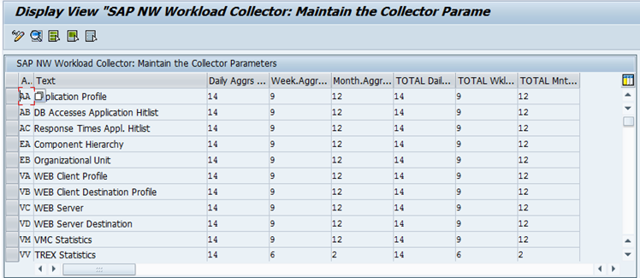
Figure 16 – SAP ST03N workload collector views retention period
Here you can define retention period for Daily/Weekly/Monthly Aggregates Retention Period workload data for specific view. In figure 16, daily aggregates data would be kept for 14 days only – after they would be deleted automatically.

2.4.2 Statistics Records – Online parameters
ST03N allows you to change online parameters to influence statistics data generation on the fly – you navigate to the screen, overwrite the data and save the changes. Your changes come into effect immediately upon saving. It can be lost immediately after the system is reboot/restarted as well.
Double Click “Dialog Step Statistics” under path “ST03N-> Collector and Performance DB -> Statistics Records & File->Online Parameters”, you would see following screen
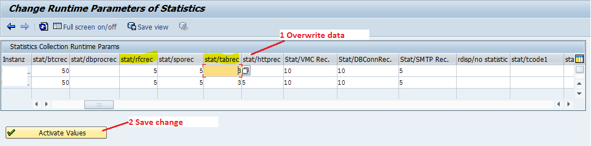
Figure 17 ST03N online parameters of Statistics
- SM04
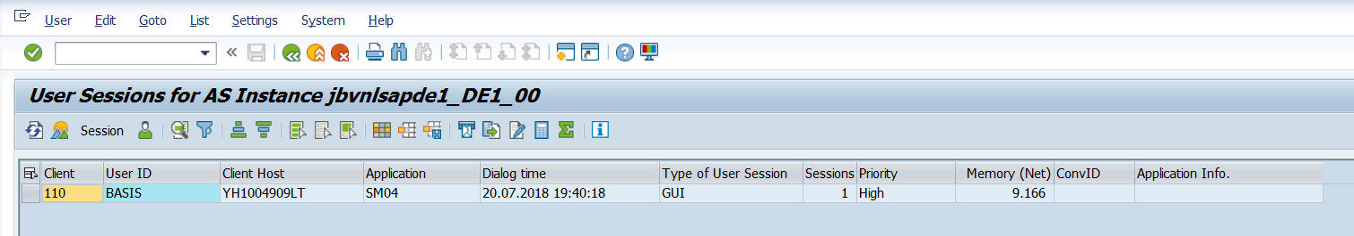
Go to transaction code SM04. Find the particular user whose session you want to delete. Double click on the user and click on End Session
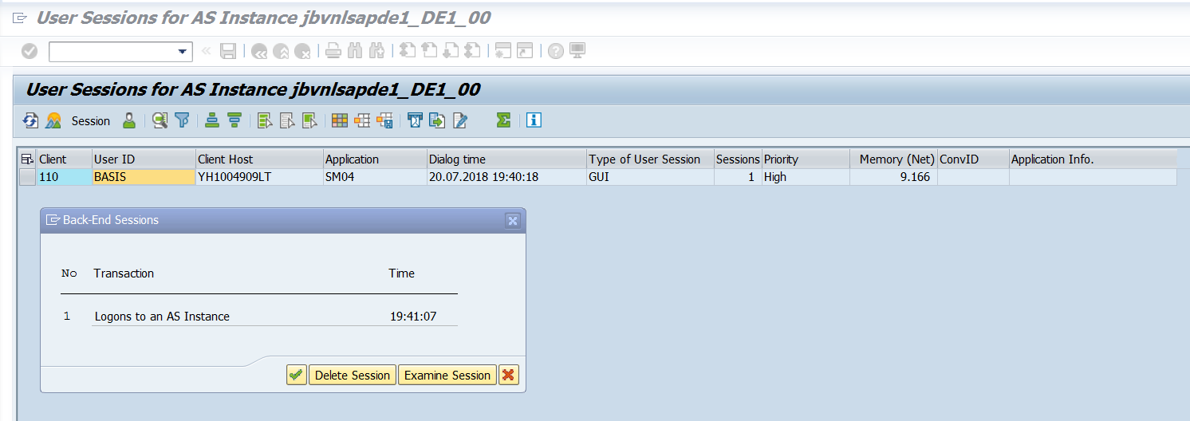

- SM12 : Lock Concept

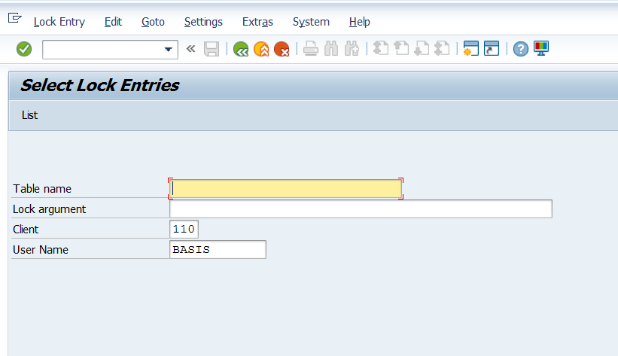
The SAP System is equipped with a special lock mechanism that synchronizes access to data on the database. The purpose of the lock mechanism is to prevent two transactions from changing the same data on the database simultaneously. Lock entries are usually set and deleted automatically when user programs access a data object & release it again. The lock mechanism is closely related to the Update Mechanism.
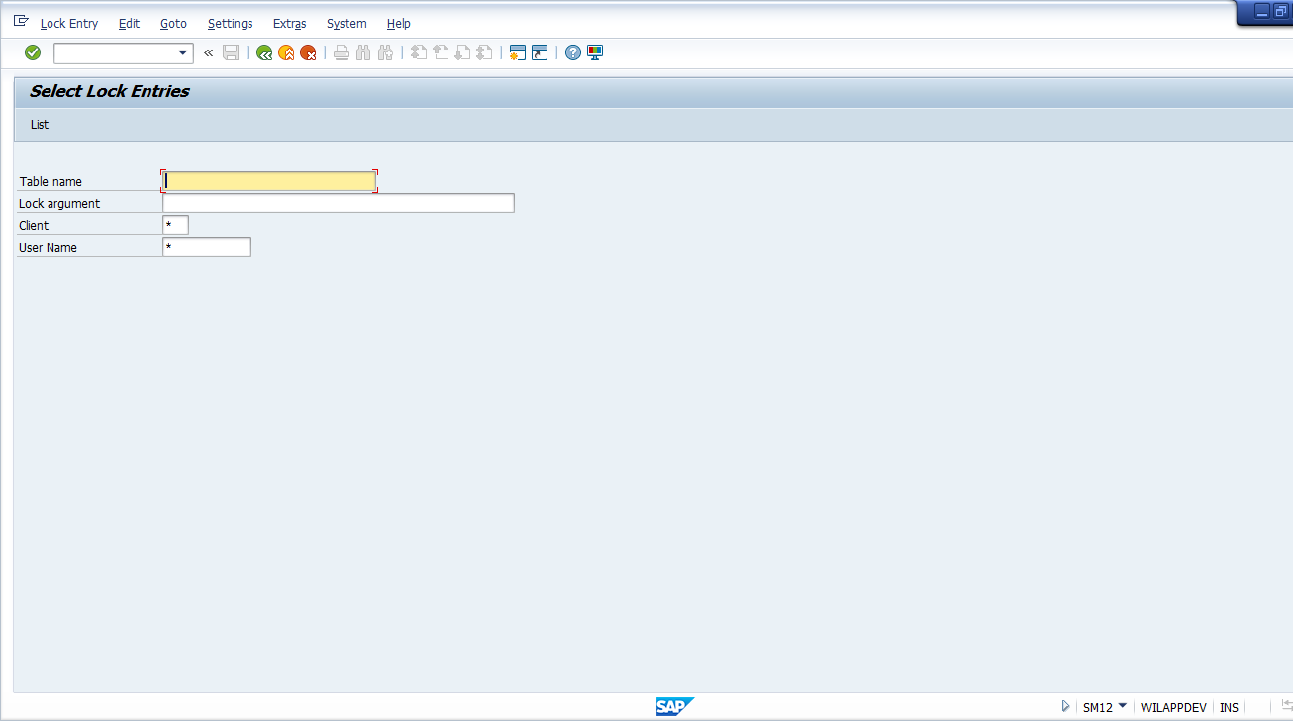
Put * for all client or else provide client No
Put * for all user lock entry
- You can use SM12 to check and delete lock entries.
2. In SM12, check any lock entry older > 2 days. If any outdated entry found, check the corresponding user is user online/offline in AL08 or SM04 (you can get the transaction code that been use by the user). Get the user contact from SU01 and inform about the lock else if the user is offline, release the table from lock by deleting the lock.
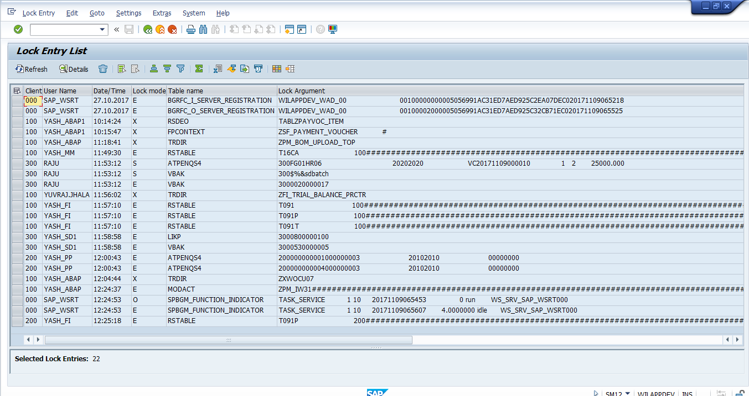
Will see all lock entries
Important profile parameters for the lock concept:-
• enque/table_size – Size of the lock table managed by the enqueue server in the main memory. The lock table contains information on which locks are currently held by whom. You can check whether the update server is functioning correctly, since the lock table can grow very fast if the update function stops. If no update problems exist, you can use this parameter to increase the size of the lock table. Default value: 4096Kb
• rdisp/wp_no_enq – Number of enqueue work processes that are to run on this instance.
• rdisp/enqname – Name of the application server that provides the enqueue service.
The lock mode:-
• Shared Lock (S) – Several users can access locked data at the same time in display mode. Requests from further shared locks are accepted, even if they are from different users. An exclusive lock set on an object that already has a shared lock will be rejected.
• Exclusive (E) – An exclusive lock protects the locked object against all types of locks from other transactions. Only the same lock owner can reset the lock .

- SM13 Update Requests:
Update management supports different status for update requests. These status are displayed in Update Management (transaction code SM13) in the column Status. The status indicates the phase of the update process that the request has reached, or in which the request has become “stuck”. The background of the status field can be green (not yet processed, currently being processed), yellow (not yet processed, probably “stuck”), or red (terminated with error). The column Info provides further information.
The dialog work process passes the update request onto an update work process after the dialog area has been completed. This then processes the V1 update modules. When the ABAP statement COMMIT WORK is received, the data is written to the database and the V2 update is output to a V2 work process (providing V2 modules exist in the update request). The following statuses are possible during this phase:
• Initial:
The update request has been created, but has not yet been completely processed. (This status applies from the moment the dialog work process transfers the update request to the update work process to the COMMIT in the update work process).
• Error:
An error occurred in the init phase, which prevents the update from being carried out.
• Error (no retry) :
The update request has been canceled and the update cannot be repeated.
• V1 Processed:
The init phase has been successfully completed, and the V2 modules are being passed on for further processing. If no V2 modules exist, this update request no longer appears in the overview.
• V2 Processed:
The V2 modules have also been processed correctly, but there is still a collective run (can be regarded as V3) to be carried out. If there is no collective processing to be carried out, this update request no longer appears in the overview.
• Processed:
If the parameter rdisp/vb_delete_after_execution is set to 2 – in other words, if automatic deletion is deactivated – an update that has been successfully completed has the status ok. If automatic deletion is activated (default), the update record no longer appears in the overview.
• To Delete:
This update request has been marked for deletion.
• Enqueues Deleted:
The SAP locks belonging to this update request were manually deleted (Trannsaction code SM12).
The following statuses are possible if an external transaction monitor is used:
• Prepared:
The update request is ready for processing and is waiting for an external transaction monitor to initiate processing.
• Cancelled:
The external transaction monitor has canceled processing. This status can follow on from status prepared.
• Error (ext. Commit) :
The external transaction monitor has started processing, but the SAP system then canceled the update request. This status can follow on from status prepared.
An update record may become “stuck” in the status init without switching to the error status err. If the record remains set to the status init for a prolonged period of time, the record can then be updated in the following ways. The statuses listed below are then active (also see graphic).
• Auto (dia):
The system administrator has manually processed the update record using transaction SM13 (Update requests > Repeat update). The dialog work process (WP1) transfers all of these update requests to an update work process (WP2) during which time the update record is set to the status auto (dia).
• Started:
The work process WP2 collects the requests and passes them on in batches to a further update work process (WP3), which then performs the actual update. The record has the status Started up until COMMIT in WP3.
• Auto (sys) :
Each time an update server is restarted, the update server checks to determine whether the update requests are set to init. If any update requests are set to init, the update server initiates automatic processing of the requests by means of update work processes. This takes place in the same way as when the update is started manually, except that an update work process (WP4) starts everything and not just a dialog work process. The update record is then set to the status auto (sys).
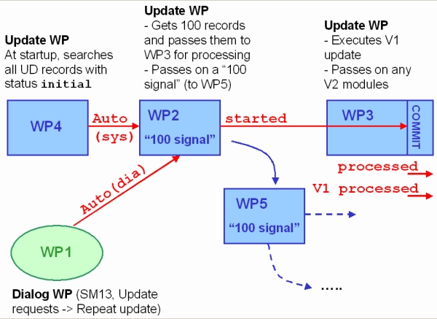

If, under exceptional circumstances, the update is not successful the first time, the status Started corresponds to the status initial when the update is repeated. If the update becomes “stuck” in the status auto or started, the status must be reset, as only records with the status initial can be entered using the methods described.

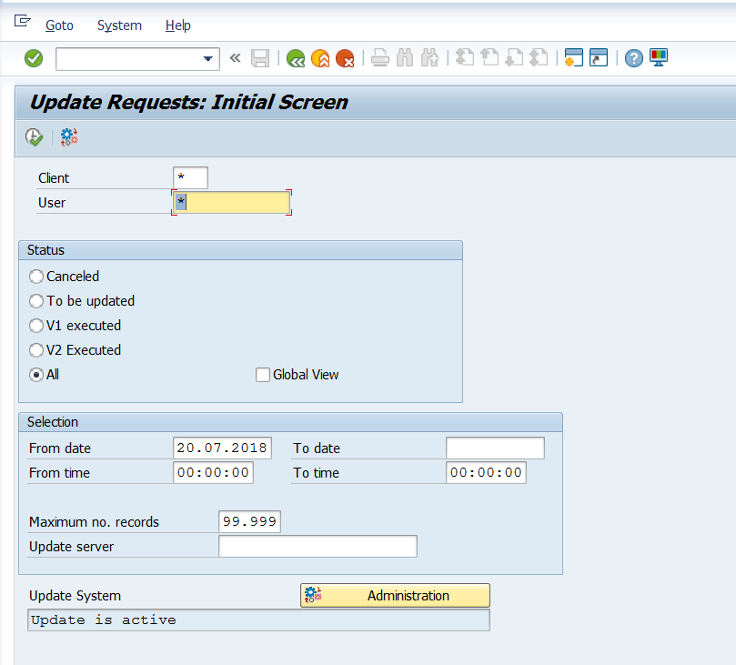
SM13 to use check Update Request
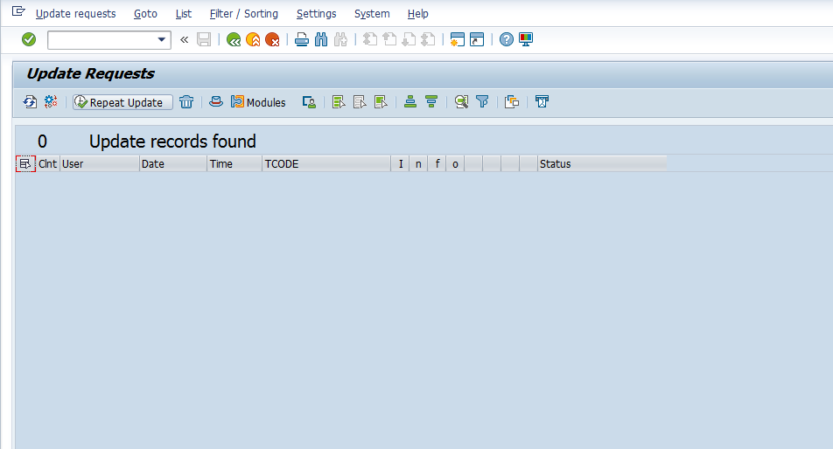
Using transaction code SM13. In the Update Request overview, select the update requests you want to delete. Choose dustbin icon, or Update requests > Delete.

- SMGW: Gateway Monitor

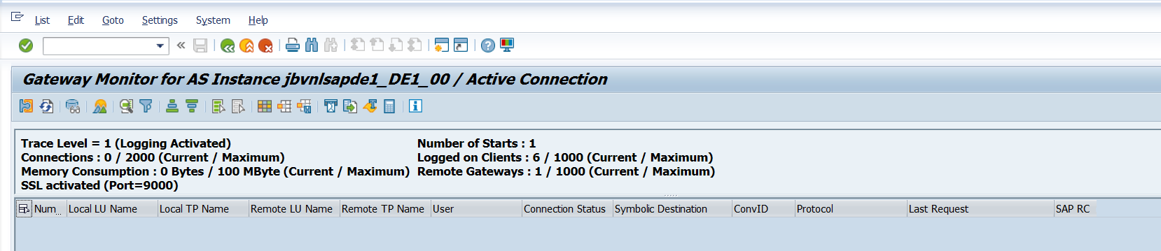
Gate way (G)
A. It is used to communication between the sap systems to non-sap systems.
B. There will be only 1 gate way for each instance.
C. In sap level gateway monitoring is - SMGW
D. In O.S level gate way monitoring is – DEV_RD
Path is – usr\sap\<Sid><instance (number)>\work\dev_rd
E. We can check also DEV_DISP, i.s dispatcher for log files
F. usr\sap\<Sid>\instance<number>\work ----> work directory stores log of the
Work process information in the format of DEV_W*
- SP01 Spool request Monitor:
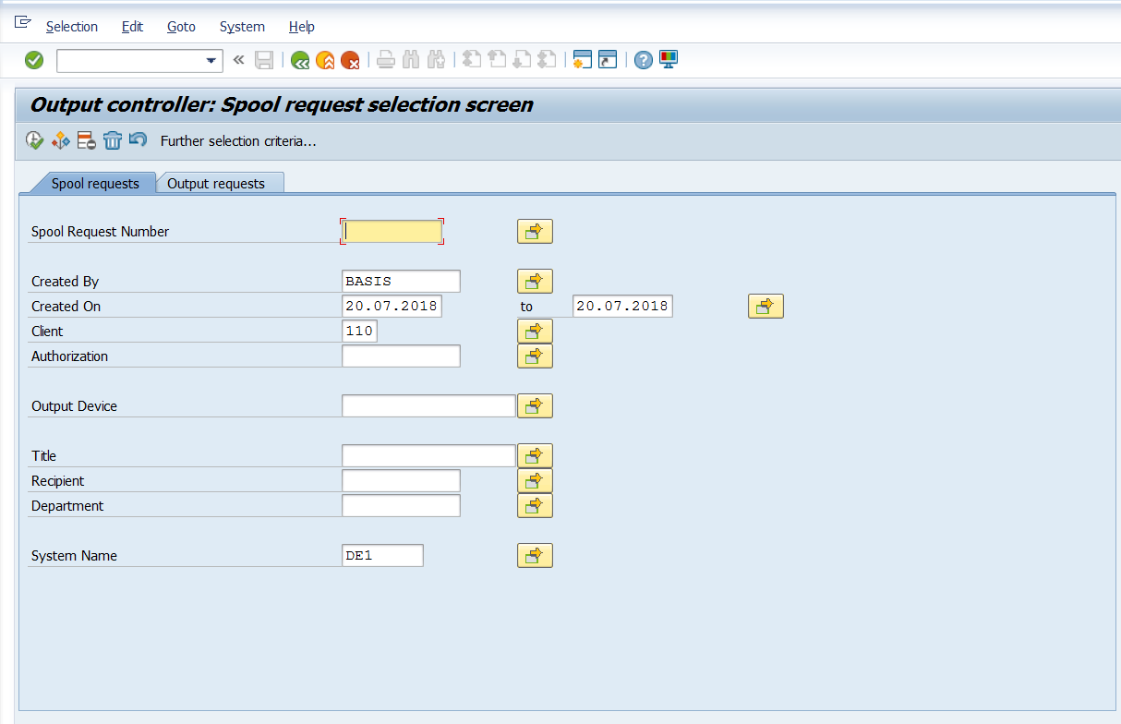
Put * in Spool Request Number Filed-* on Created by filedprovide date on created on field and click on execute button.

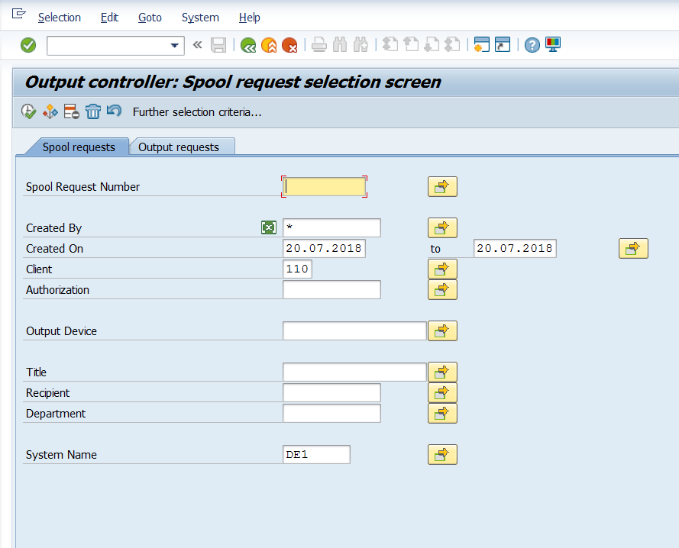
Click on execute command.
Spool (S)
A. It is used to print the documents to a printer
B. There should be at least 1 spool process in the entire system
C. The spool profile parameter name is – rdisp\wp_no_spo
D. Dialog work process (or) background work process are creates a spool request. i.e.
To print the documents
E. In O.S level spool request are stored in global directory usr\sap\<Sid>\sys\global
F. The storage location specific parameter name is – rdisp\store_location
G. This parameter has 2 values they are global_G and database_DB.
H. G means it stored in global directory DB means it stored in database tables are
“TST01” and “TST03”
I. The spool request is also referred as TEMSE
Temse is used for temporary sequential objects
J. Access method: It is connection to spool server to O.S spool.
Access methods are 3 types
1) Local access method: the spool process and the spool host (printer spool)
reside on the same system. Access method type L is used for UNIX O.S
and C is used for windows O.S
2) Remote access method: the spool process and the spool host reside on two
different systems. Access method type U is used for UNIX O.S and S is
used for windows O.S
3) Front end method: access method p is the printers are connected to end
users desktop do not configured to many front and printers F and G
4). we can see all the clients and users spool request T_Code is – SP01
5) We can see specific client and user spool request T_Code is – SP02
6) Spool administration is - SPAD
7) Default printers are – SWIN, SAPWIN
I) SP02: We can see specific client and user spool request
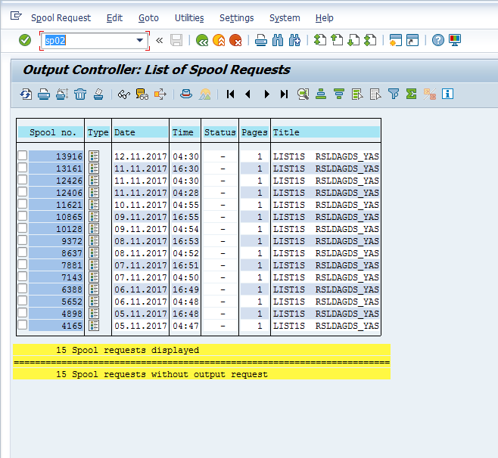
SP02: It showing spool request of current USER

SP11: Display SAP Temse Objects
The transaction code SP11 is used to display the list of temse objects available in the SAP system. You can specify the object name or just click on List objects to get all the temse objects.
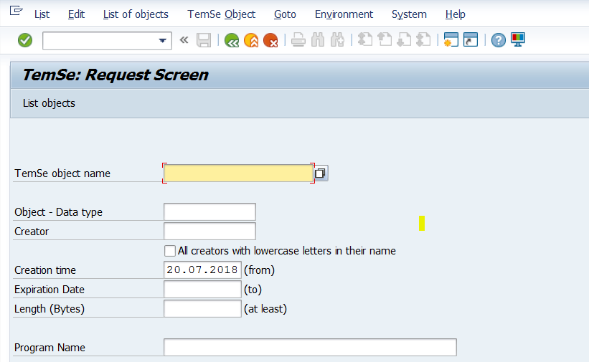

You will get the following screen and to get into details of the following objects – just double click on it.

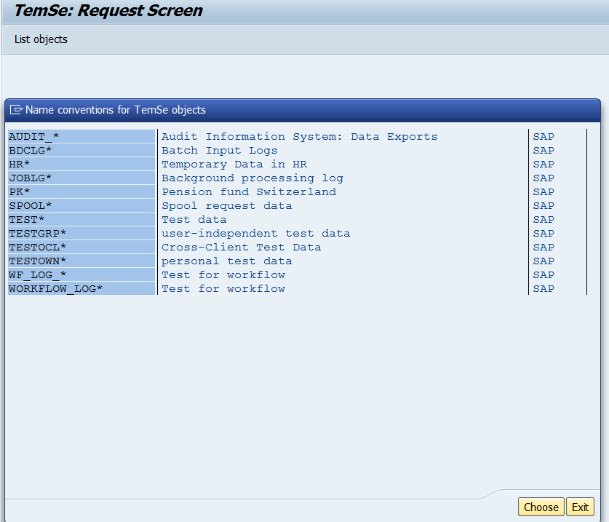

The following details will show the Attributes in 2 parts. So, you can click on each Attributes to get further information.

- SP12
You can display the distribution of the storage space among the TemSe objects.
1. Call transaction SP12.
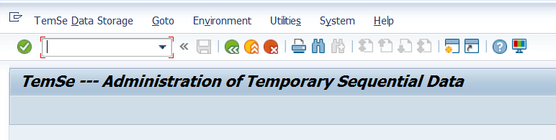

- Choose TemSe Data Storage > Memory Allocation.

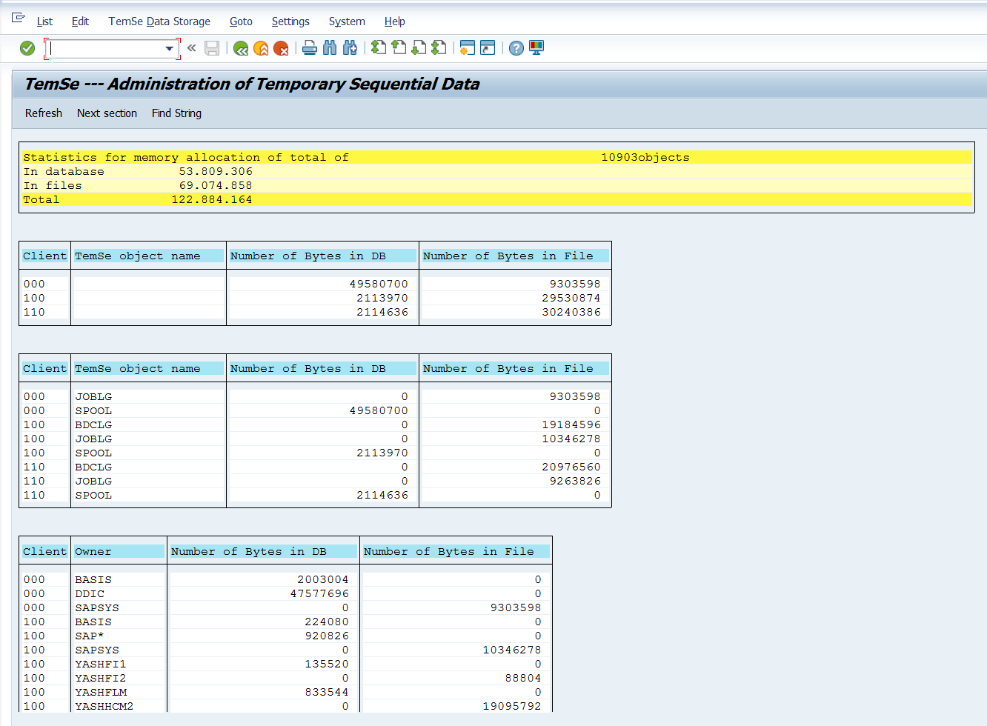

The TemSe – Administration of Temporary Sequential Data screen appears. The system displays a large overview of the TemSe objects. You have the following options:
• You can check the number and size of the TemSe objects.
• You can check the number of objects that are stored with an unlimited retention period.

Note
You can only determine the total number of objects with unlimited retention periods. You cannot explicitly check the retention period of spool requests in TemSe administration. It is display in the header data of the spool requests (transaction SP01).

L) SM21: System Logs Analysis
Transaction code SM21 is used to check and analyse system logs for any critical log entries. The SAP System logs is the all system errors, warnings, user locks due to failed log on attempts from known users, and process messages in the system log.

The list can be restricted for Problems Only, Problems and message and all messages. The information in this list can further used to analyse the errors which are indicated with Red sign under Priority. Also we get information of Tcode that was used by the user when the error got generated. There are to two different types of logs created by the system log:

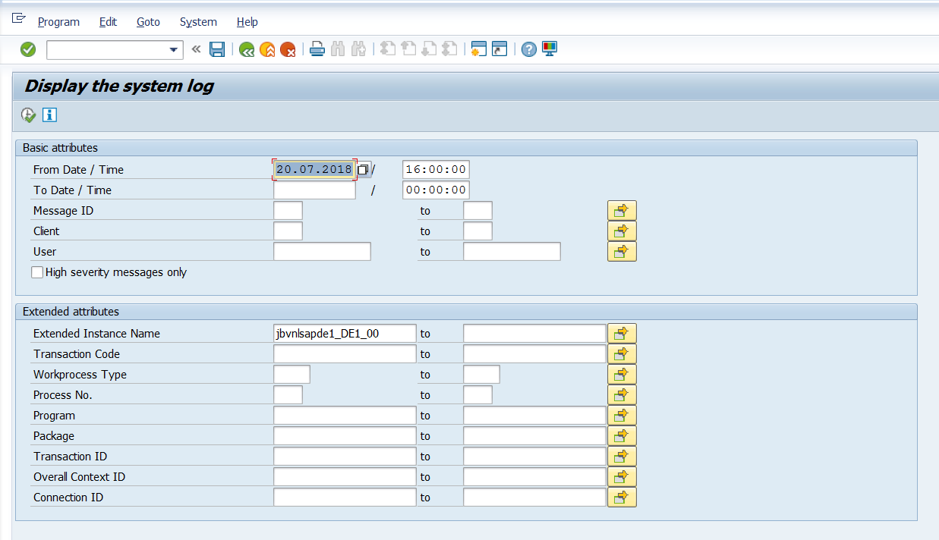
Provide Date and time which you want to Check. User and client specific
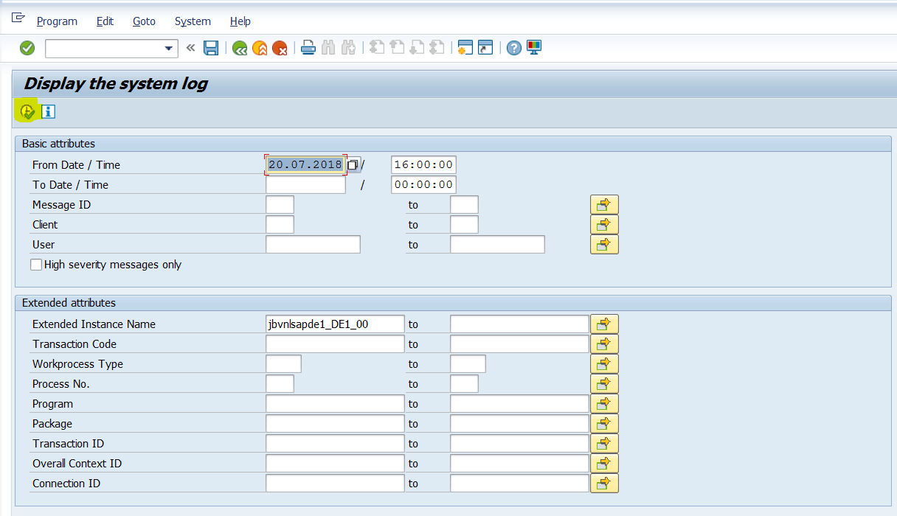
After all you have to click on Execute Button as mark in red in above screenshot.

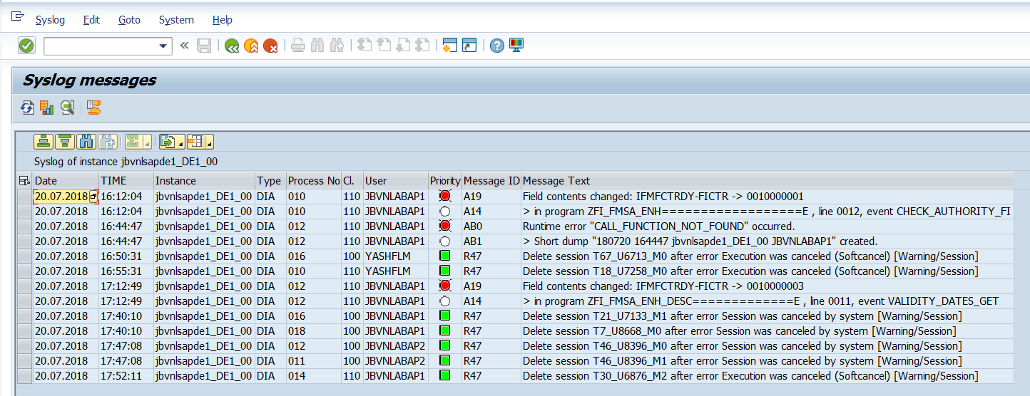
You will get above Summary.

M) SM36: Define Background Jobs:
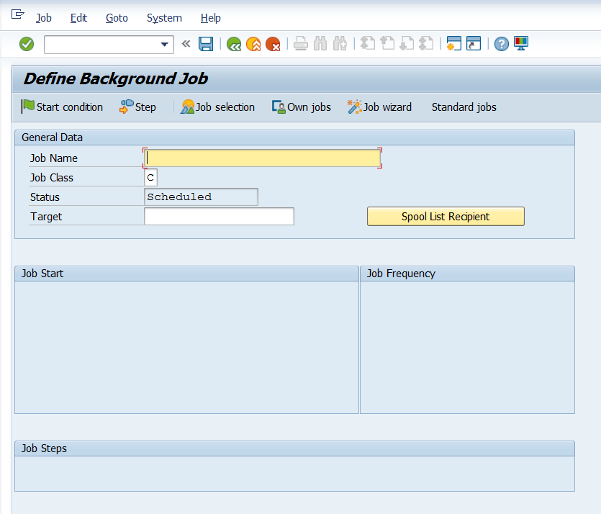
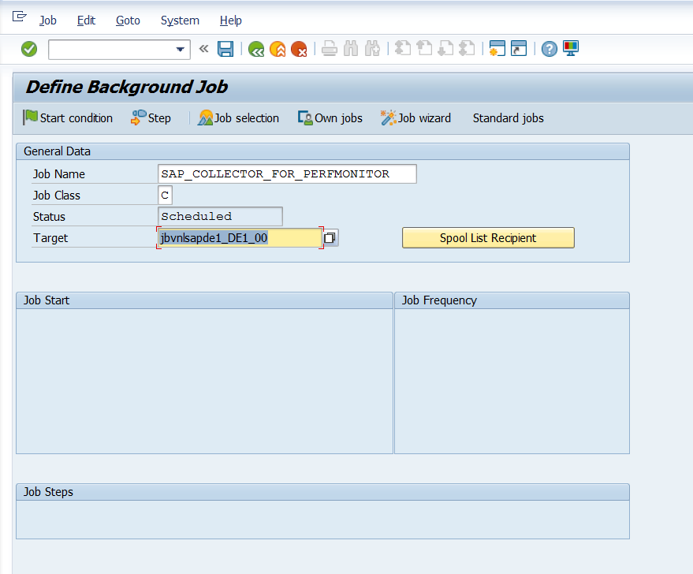
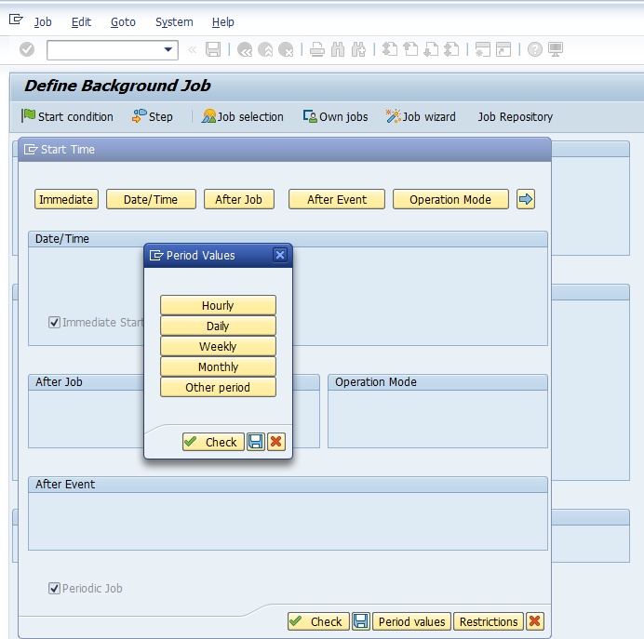
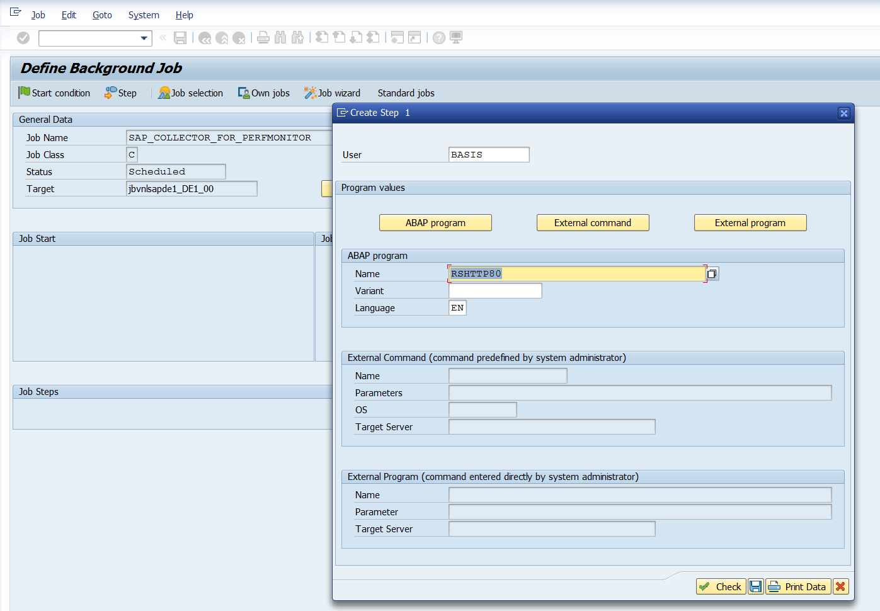
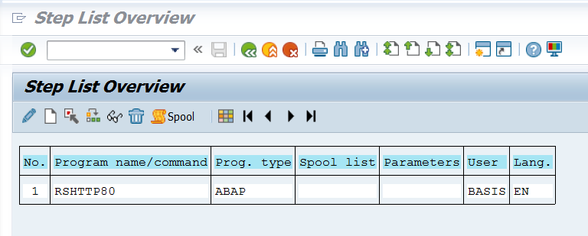
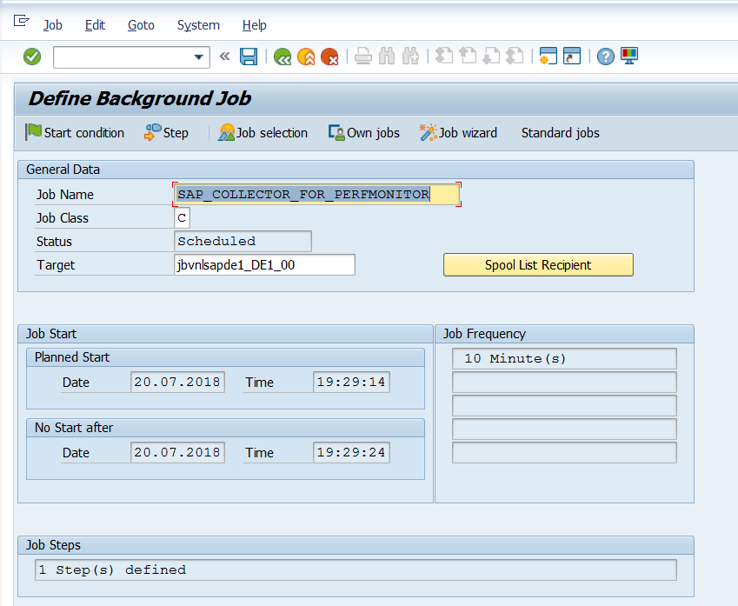
- SM37: monitoring background jobs:
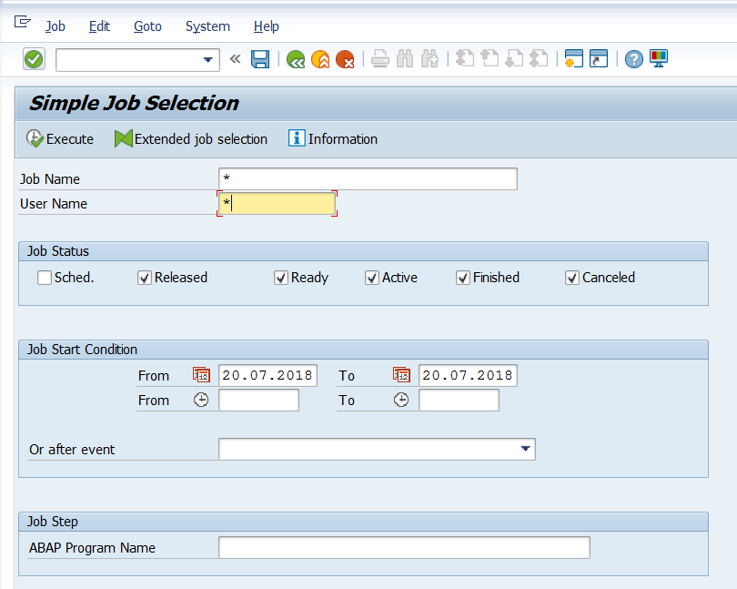
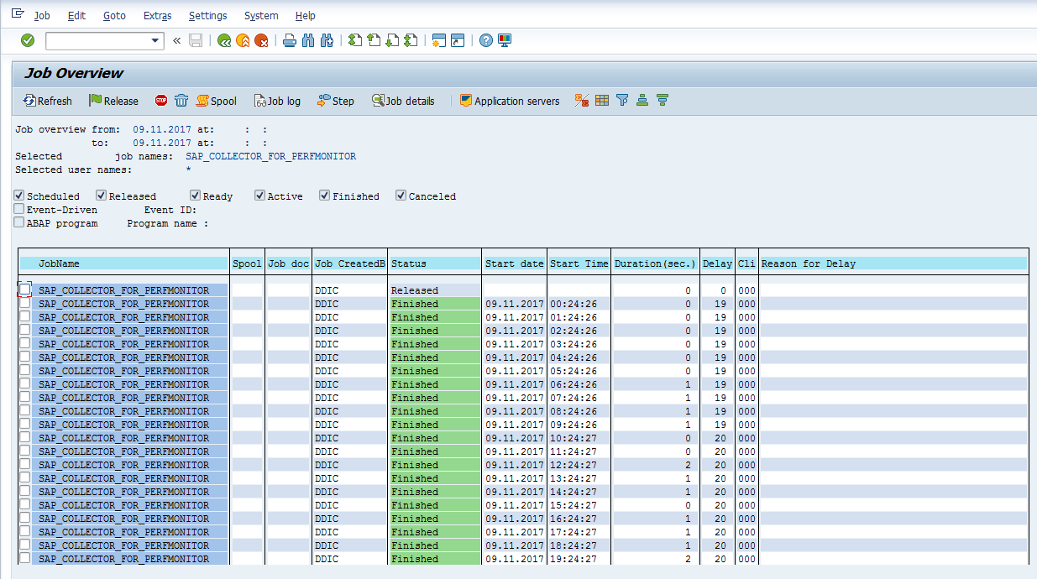

Transaction code SM36 is used to define and schedule the background jobs. You can define and schedule background jobs
• Directly from Transaction SM36. This is best for users already familiar with background job scheduling.

ST02: PERFORMANCE ANALYSIS IN SAP MEMORY/BUFFER AREA

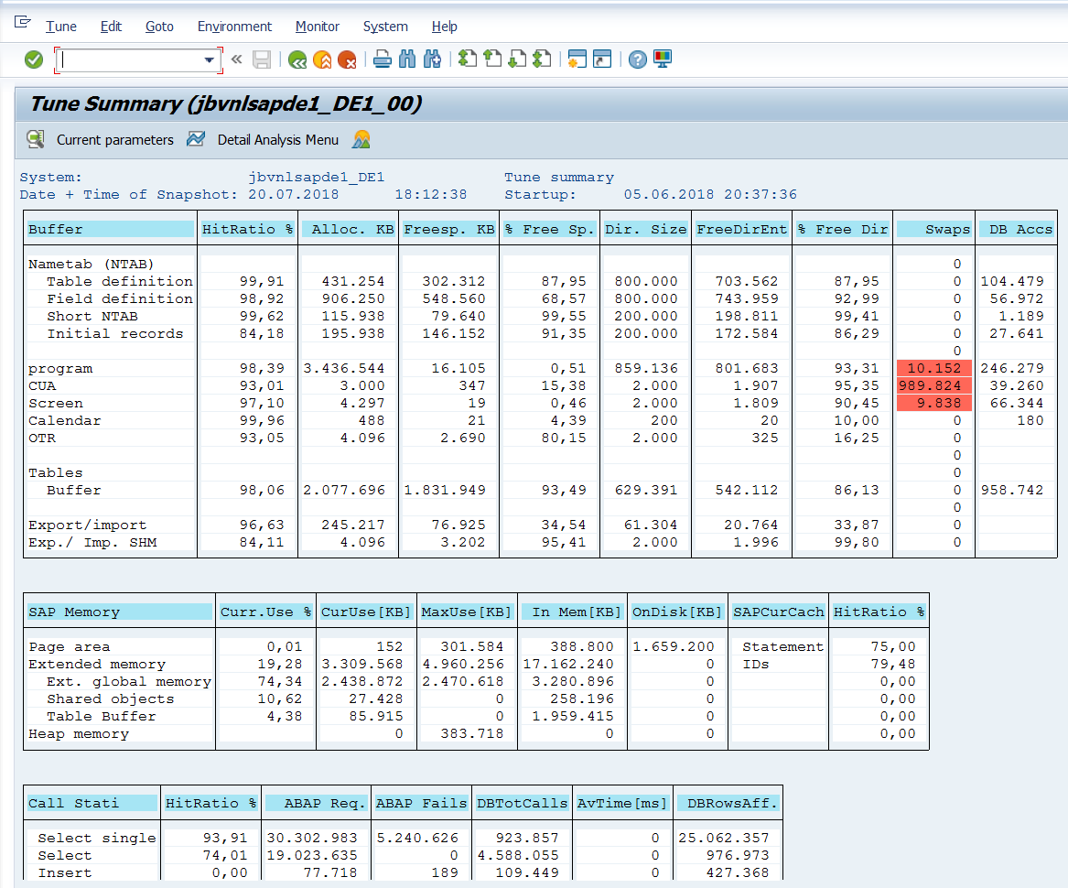
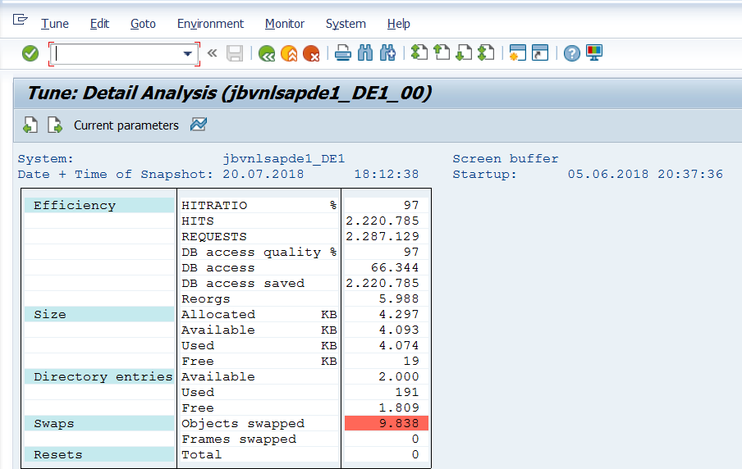
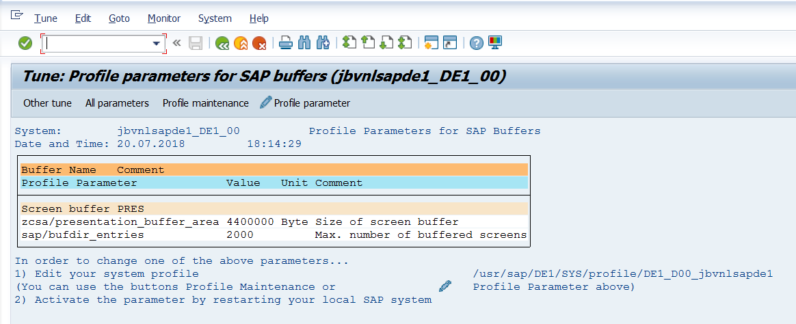

Buffer section explanation
Column field explanation
Screen Field | Explanation
Buffer | Type of buffer like nametab, Program etc.
Hitratio % | Namely buffer quality =( total access – physical access)/ total access x 100%.
Alloc. KB | Configured or allocated memory space for the buffer type in question.
Freesp. KB | Free space = allocated memory space – occupied memory space.
Dir. Size | Maximum number of buffer objects that can be kept in the related buffer.
FreeDirEnt | Free Directory Entry = Directory Size – used Dir Entry.
% Free Dir | = free Directory / Dir. Size X 100%.
Swap | Number of buffered objects which has been swapped to page area.
DB Access | Number of data transfers from the data base to the related buffer.

SAP Memory section explanation
This section shows configured memory/virtual memory for a list of sap memory type and their memory usage.
Column | Explanation
Sap Memory | Show type of SAP memory
Curr. Use % | = allocated memory/total-memory X 100% for the type of memory in question
CurrUS[KB] | Currently used memory at the instance
MaxUse[KB] | High-water mark since the SAP instance is started
In Mem[KB] | Configured total memory
OnDisk[KB] | Configured disc space(Virtual memory),only eligible for Page memory and roll memory.
SAPCurCache | SAP Cursor Cache
HitRatio | Applicable for ID and statement Caches.

SAP Memory Quotas screen
Column | Explanation
texts | Sap tasks type like dialog, background etc.
Step | Sequence allocation – next memory area only if memory allocated in previous steps is not enough.
Memory type | 3 possible memory types under current SAP design: Roll, Extended and Heap
Amount | Configured the memory size for the tasks.

- ST06 Operating System Monitor
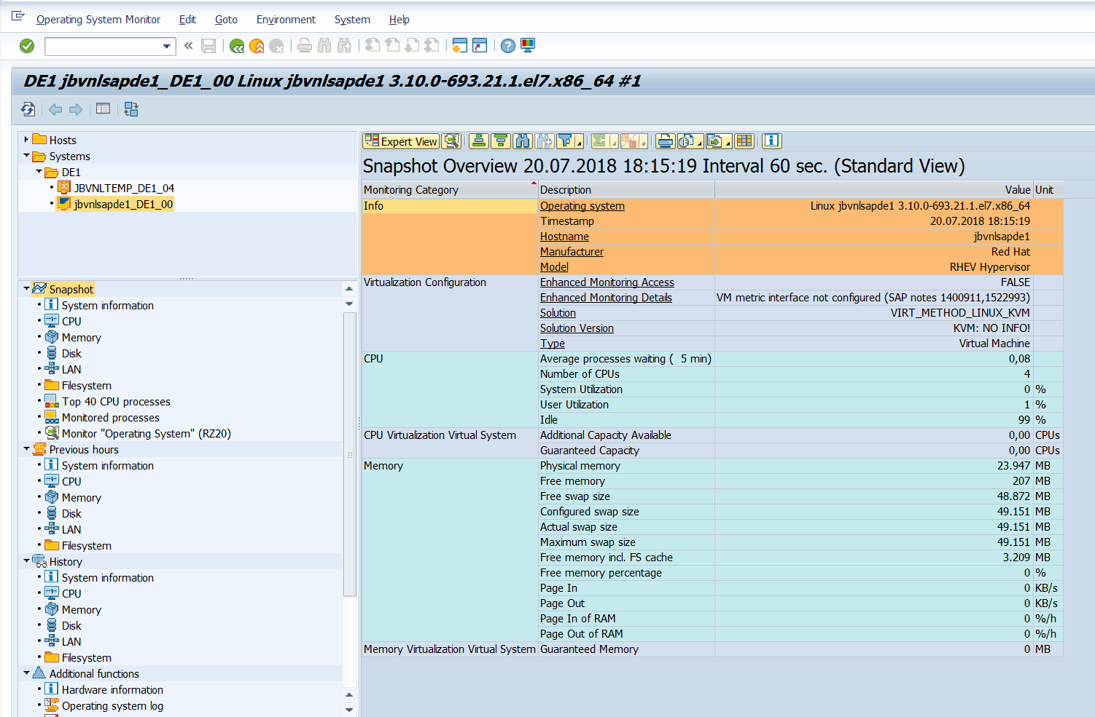
Operating System Monitor CPU, Memory, DISK, LAN and filesystem etc

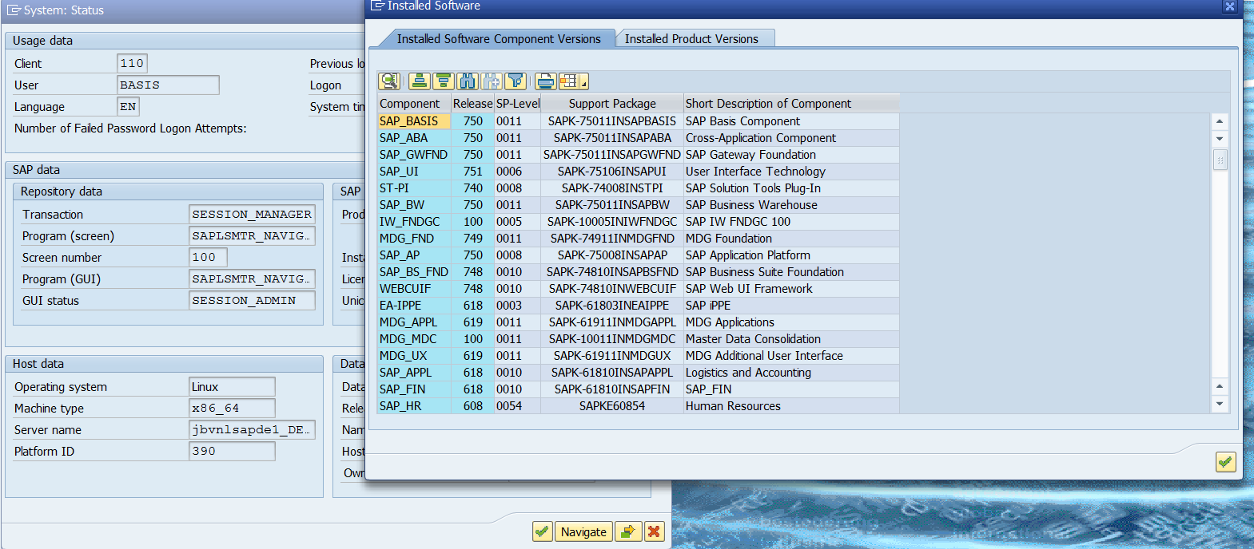
To check component version of SAP go to SYSTEMStatusclick on component icon you will get all the information.

3) Steps to Create a New Client in SAP
Follow these steps to create a new client in SAP system:

Step 1: Start by using transaction code — SCC4
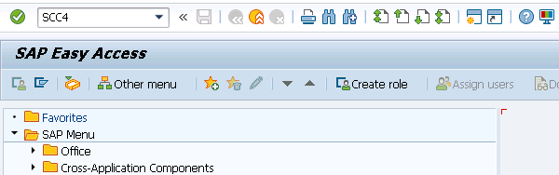

Step 2: To create a new client, enter the below details after clicking on New Entries.
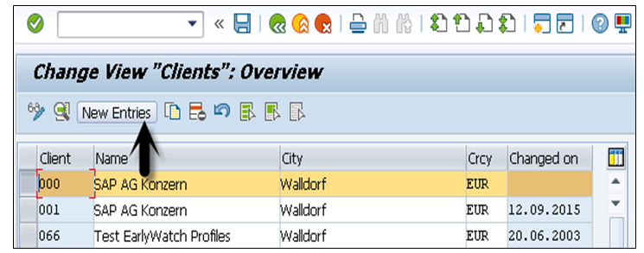
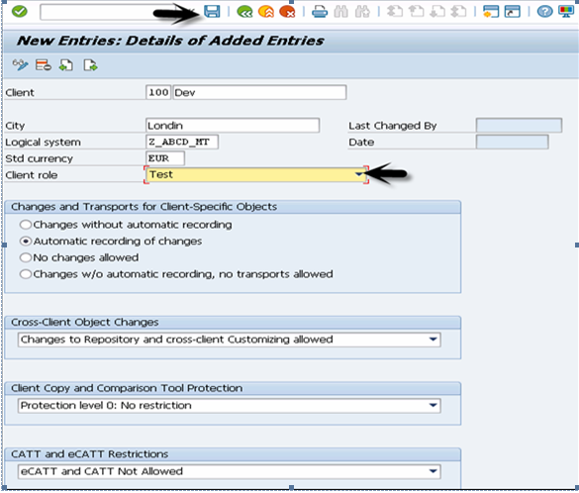
Step 4: Now, if you go to the Display Client list, Transaction SCC4 > Display > New client will be added.

Local and Remote System

You can also create a copy of existing clients between local and remote system IDs. Follow these steps to create a copy of existing clients:
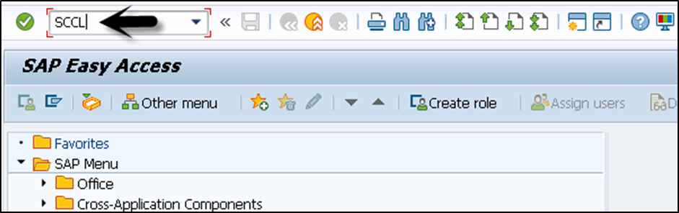
Step 1: To create a copy of a client in local SID, the transaction code is SCCL.

Step 2: Enter the following details:

Select your desired profile, enter source client, and enter description.

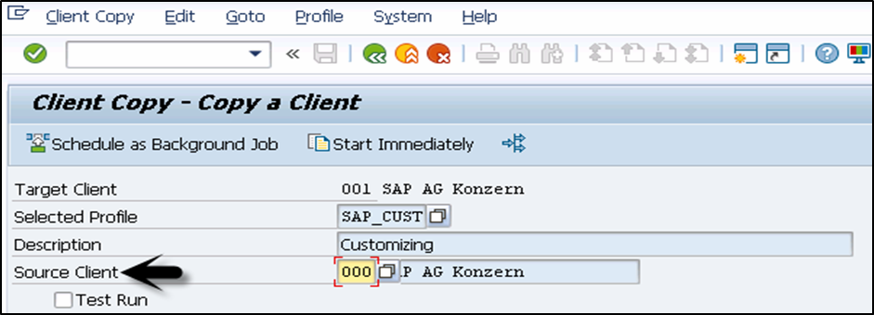
Step 3: By default, the client copy is executed in a single process and you can distribute the workload on multiple processes to reduce time for copying.
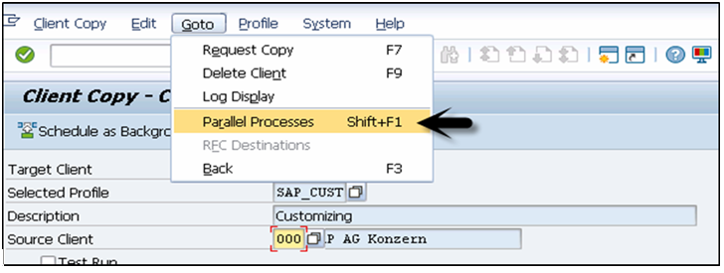
Step 4: Copying a client can take longer. Therefore, this process can be run as background job.

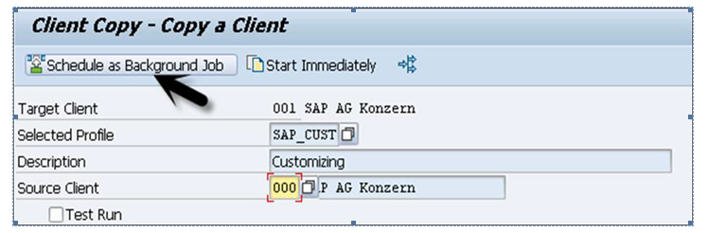
Step 5: To check the logs, transaction code — SCC3 can be used.

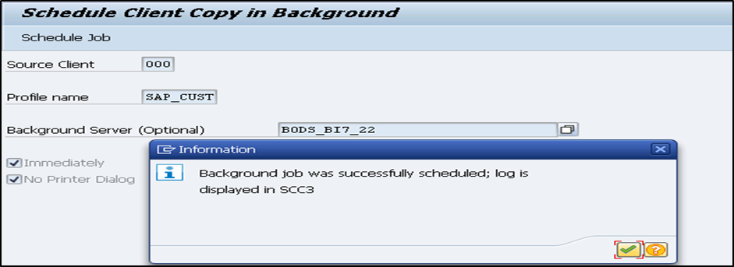

Remote System

You can create a copy of client in the remote system using transaction code — SCC9. This system uses Trusted RFC connection SM59.

Enter the details as we do for local client copy and you can select an option to run the copy in background.

To check the logs, transaction code — SCC3 can be used.

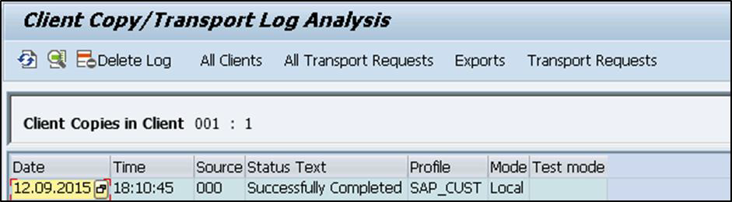

Import/Export

It is always recommended to use import/export option for client copy when database size is large.

Follow these steps to export a client:

Step 1: Log on to target system and create an entry for new target client using transaction code — SCC4. To perform export for transferring data files to target system import buffer, use transaction code — SCC8.

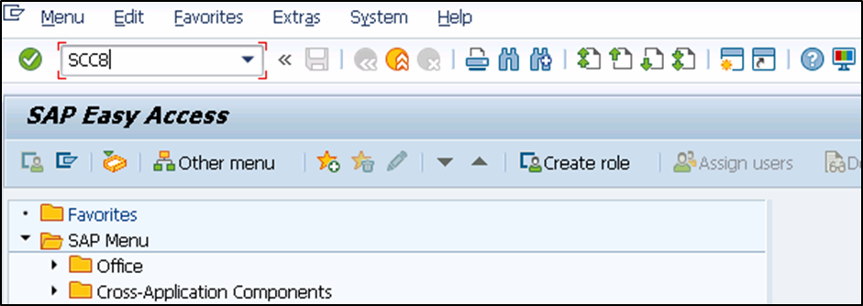

Step 2: Select the profile and target system. You can schedule the export process in background. Depending on the export type, it creates multiple transport requests in the following areas:

• To hold the cross client data.

• To hold the client dependent data.

• To hold some client dependent data.

Now, follow these steps to import a client:

Step 1: To import a client, use transaction code — STMS_IMPORT, you will see import queue.

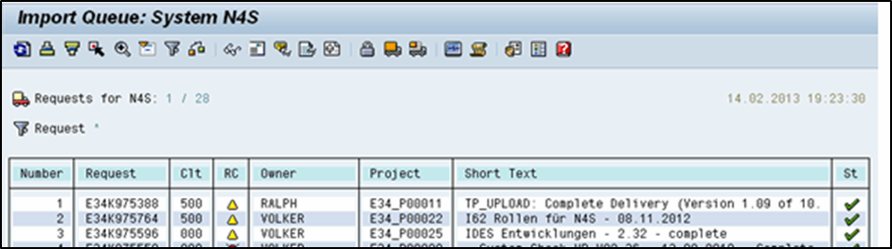

Step 2: Select the transport requests to perform import process that is generated from export operation. Once import is done, you can use the transaction code — SCC7 to complete post import phase. You can check import logs using transaction code — SCC3.

Deleting a Client

Follow these steps to delete a client in SAP system.

Step 1: Use transaction code — SCC5 as below. Go to SAP Easy Access and run the transaction.

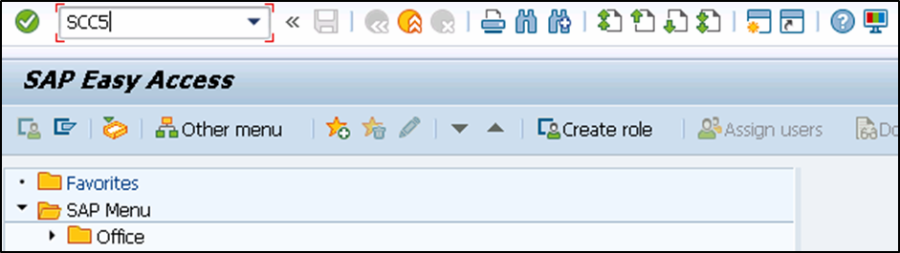

Step 2: Select the client to be deleted. You can select > delete in background or start immediately. Table T000 contains all the client entries created using Transaction SCC4. You can also select to remove table entry for the client.

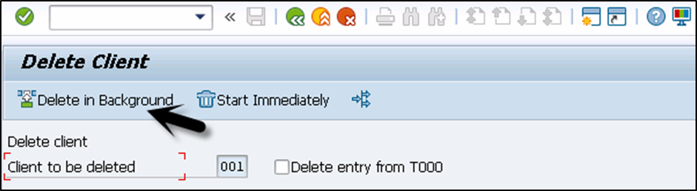

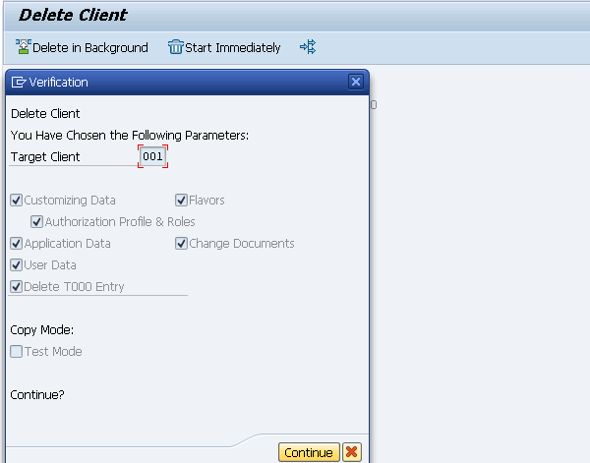
Step 3: When you select start immediately, you see the following window.

Step 4: Click on Continue to complete the deletion.

4) Creating a User

This chapter guides you on how to create user accounts in SAP.

Follow these steps to create multiple users with different access rights in SAP system.

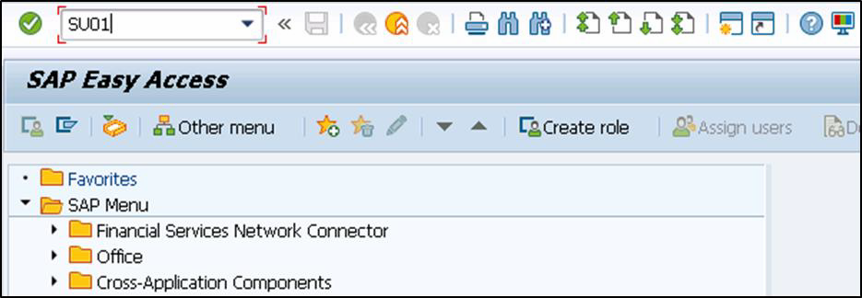
Step 1: Use transaction code — SU01

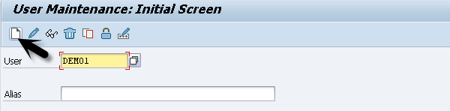
Step 2: Enter the username you want to create, click on create icon as in the following screenshot.

Step 3: You will be directed to the next tab — the Address tab. Here, you need to enter the details like first name, last name, phone number, email id, etc.

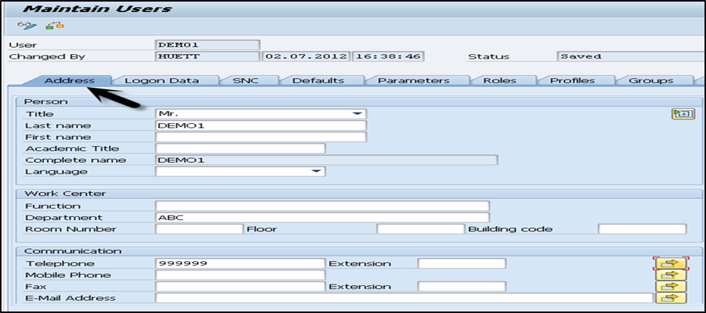

Step 4: You will further be directed to the next tab — Logon Data.

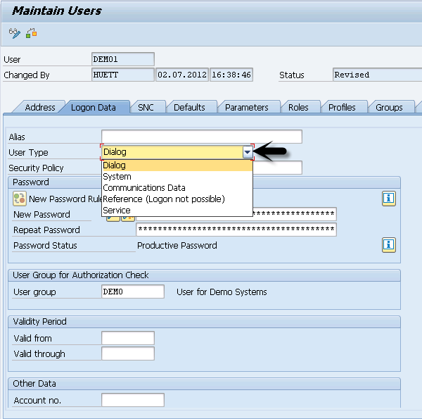
Enter the user type under Logon data tab. We have five different user types.

The following are the different user types:

• Dialog user — this user is used for interactive system access from GUI.

• System user — this user is used for background processing, communication within a system.

• Communication user — this user is used for external RFC calls.

• Service user — this user is created for a larger and anonymous group of users.

• Reference user — it is not possible to log on to the system with this user type.
User type for general, non-person related users that allow the assignment of additional authorizations.

Step 5: Type the first Login Password > New Password > Repeat Password.

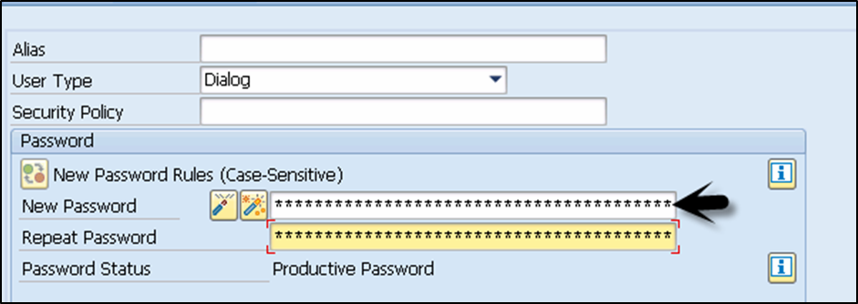

Step 6: You will be directed to the next tab — Roles: Assign the roles to the user.

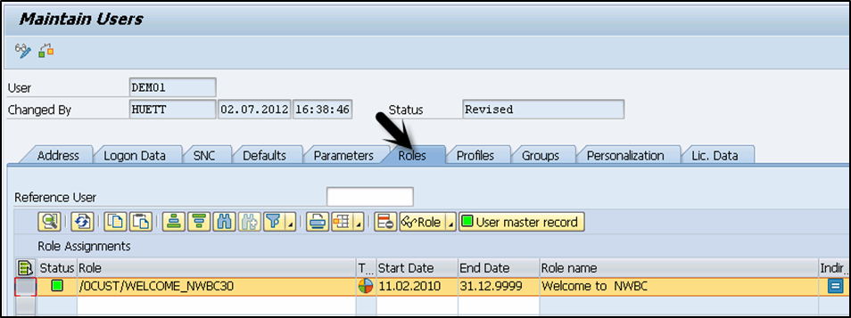

Step 7: You will further be directed to the next tab — Profiles: Assign the Profiles to users.
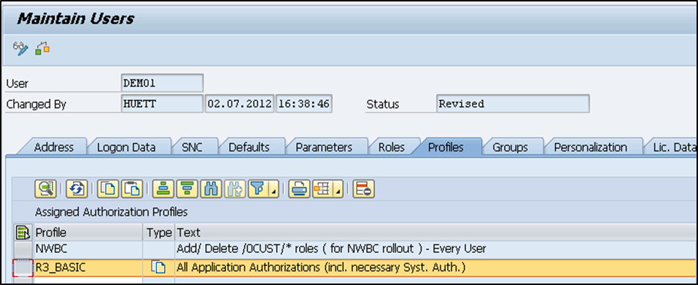

Step 8: Click on Save to receive confirmation.

Password Reset

Follow these steps to reset password:

Step 1: Use transaction code — SU01

Step 2: Enter the username and select the change option at the top to edit the profile.

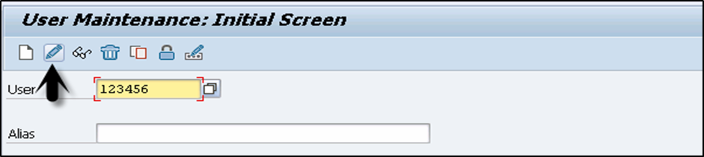

Step 3: You will be directed to the next tab — Logon Data

Step 4: Enter the new password and click on the save icon at the top.

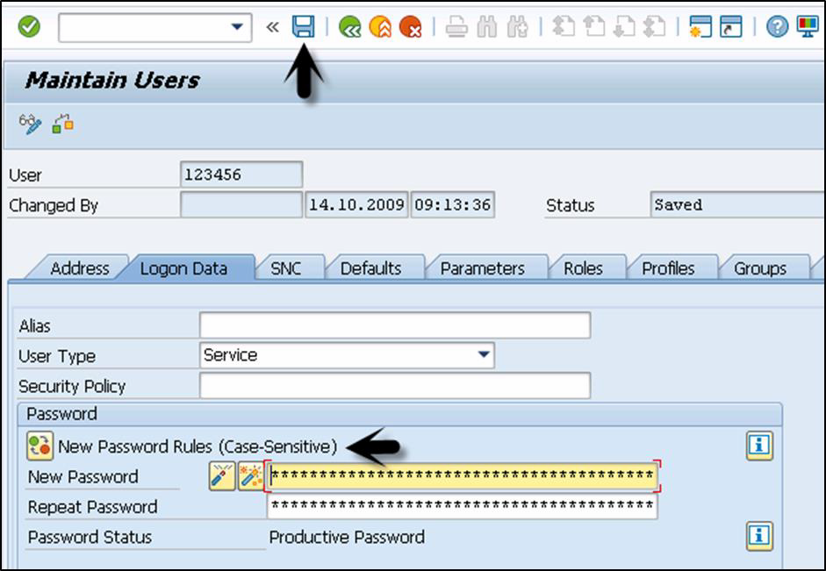

Step 5: You will receive the following confirmation:

Lock / Unlock a User

In SAP system, an administrator can also lock or unlock a user as per the requirement. This can be performed for a specific time period or permanently. A user can be locked/unlocked in the following two ways:

• Manually/Forcefully

• Automatically

Manually or Forcefully

You can lock a user forcefully/automatically using these transaction codes:

• Transaction code — SU01 for single user

• Transaction code — SU10 for multiple users

Step 1: Execute transaction code — SU01

Step 2: Select the user you want to lock/unlock and click on the icon.

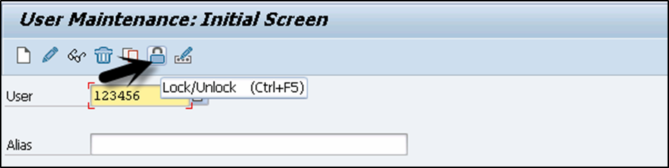

Step 3: You will now see the current status of the user. Click on lock/unlock option.

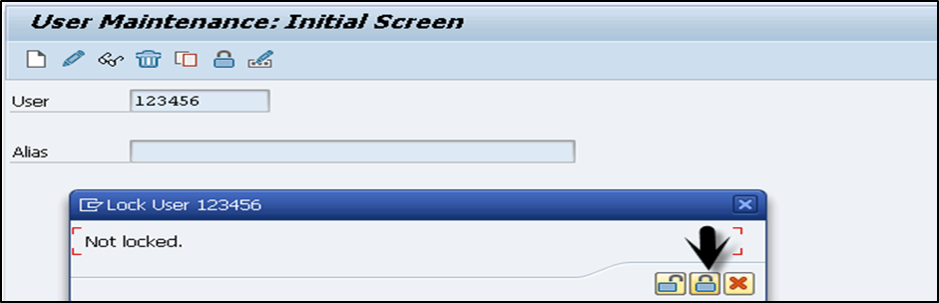

Step 4: To lock multiple users, use transaction code — SU10 and enter the users in username list. To select multiple users in one go, click and search you will get an option to select multiple users at one time.

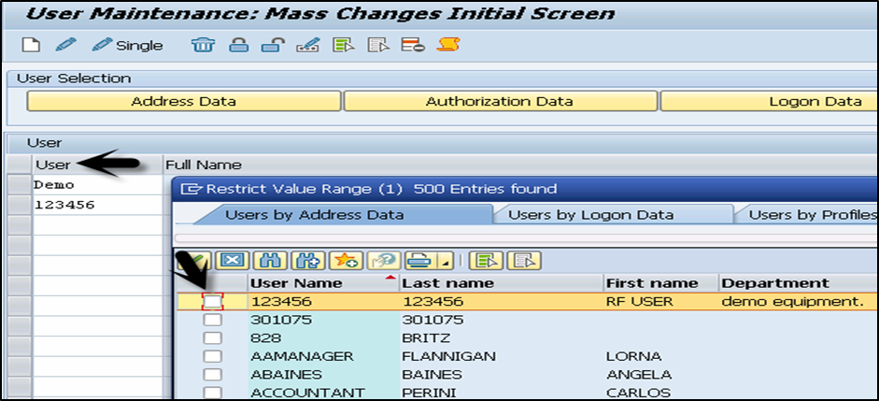

Step 5: Select the lock and unlock icon at the top as per requirement. This can be used to unlock single/multiple users using same transaction code.

5) PFCG:

PFCG: Steps to Create Customize Role and Assign Authorizations to User
Execute transaction code PFCG. Enter the Role name and choose on Single Role. (We are going to use Single Role for this activity).
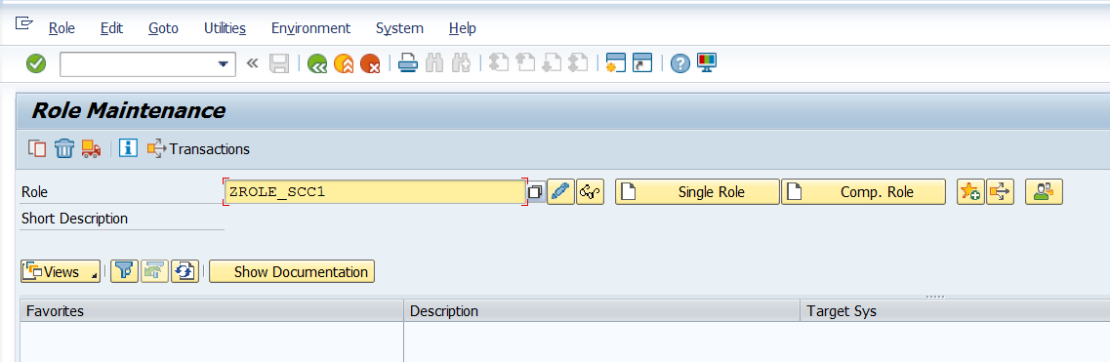
Enter the role description and press on Save. You have just completed creating a new role in SAP system. So next, you need to assign the authorizations (transaction codes, reports, authorization default, web address and files) to the SAP users.
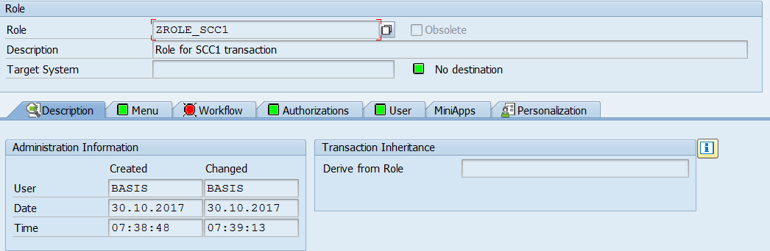
Go to the Menu tab. If you want to grant user with the transaction codes – click on Transaction. You will get as below screen and from here, you can type which transaction codes granted for the users. Once done click Assign transactions.
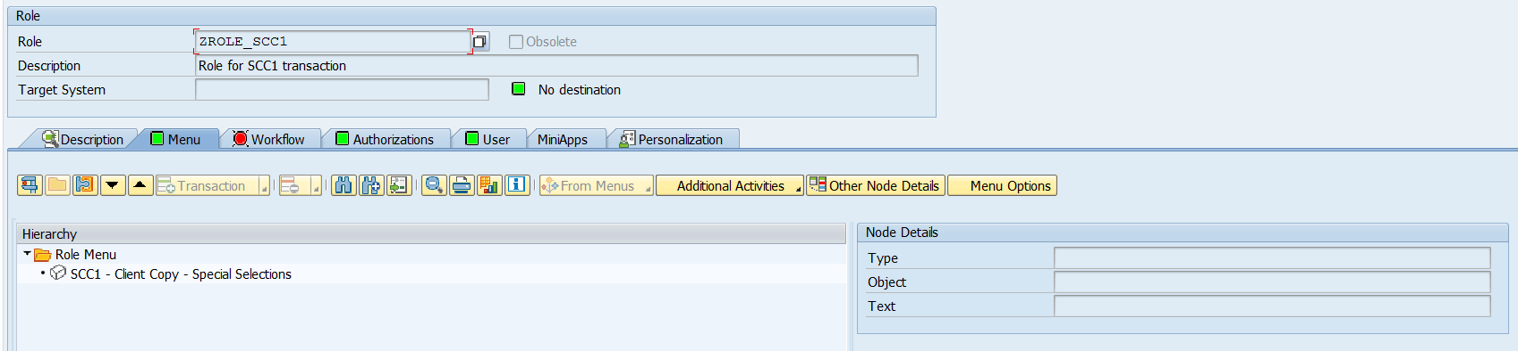
The Menu screen will list all the granted transaction codes. You also can do for the Report, Authorization Default and Other. Click on Save again.
Next, go to Authorization tab. Click on Change Authorization Data.
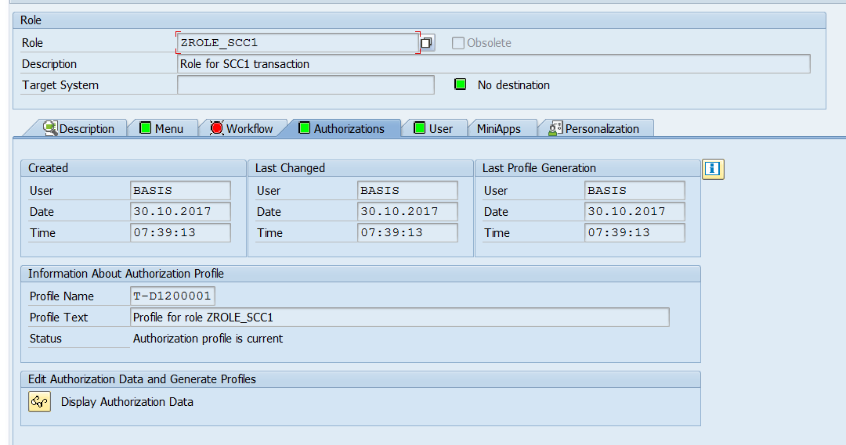
On the Change role: Authorizations, verify if there are any missing values.
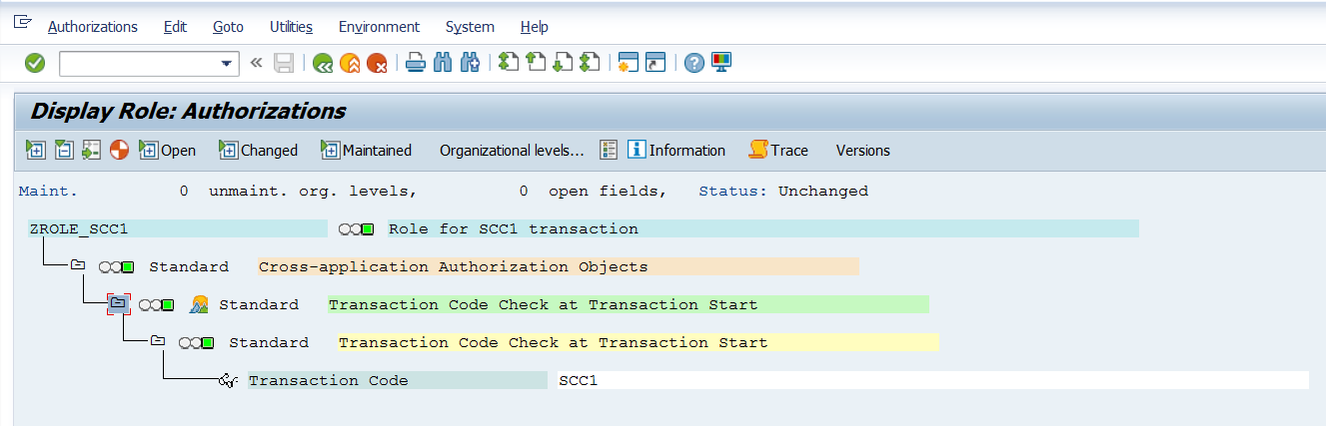
To assign the missing values – assign authorizations (make the yellow traffic light into green) – You need to click on the traffic light icon. Then, below dialog box will appear – to set the authorization fields to * (full authorization) for the object class. Press Enter.
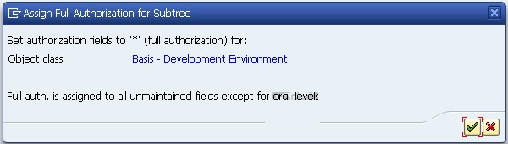
To get into details on the respective object class – authorization object – You may need to click on the pencil icon. As example below for ABAP Workbench, each task for Activity, Package, Object name, Object type and Authorization group ABAP/4 does have their own level of security. So, from the below screenshot, the Activity was only granted for Display – means user can just only display while using the transaction code. They will not have the ability to change, update, delete or other functions.
If you want to assign more ability to the user, you can click on the pencil icon. You can select from listed activities. To give all authorizations, click on Full authorization. Click on Save.

You will prompt back to the Change role: Authorizations screen, click on Save to Assign Profile Name for Generated Authorization Profile. Press Enter.

Still on the Change role: Authorizations screen, click on Back (F3) and you will get below screen. Click on Generate icon (F6) to generate the Profiles.

The profiles will generate and you will see the Profile Name, Text and Status under the Information about Authorization Profile.
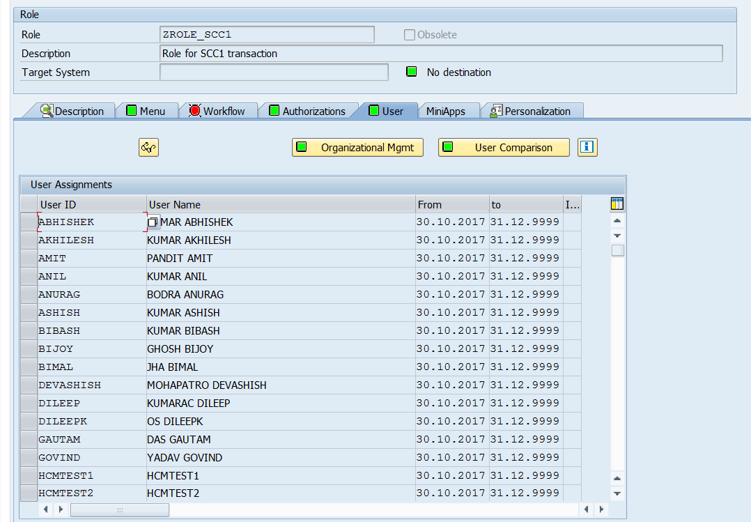
Next things to do are – Assign users to the Profile! So, switch to User tab and enter the User ID. Once done, click on the User comparison. Click on Save and you are done!
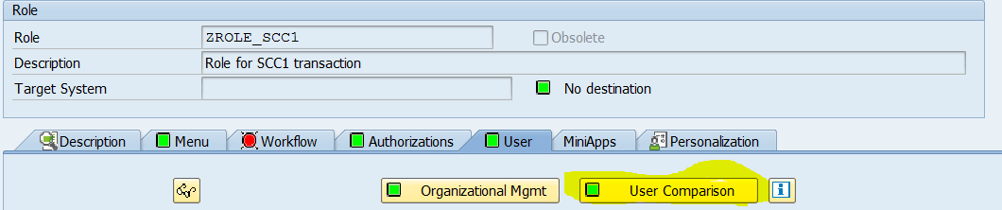

You can ask user to test the transaction codes now!

6) SUIM

SUIM: Change Documents
Share this article:
You can use this report to determine all changes to the following objects:
• A user (RSUSR100)
• A profile (RSUSR101)
• An authorization (RSUSR102)
• A role assignment (RSSCD100_PFCG)
• A role (RSSCD100_PFCG)
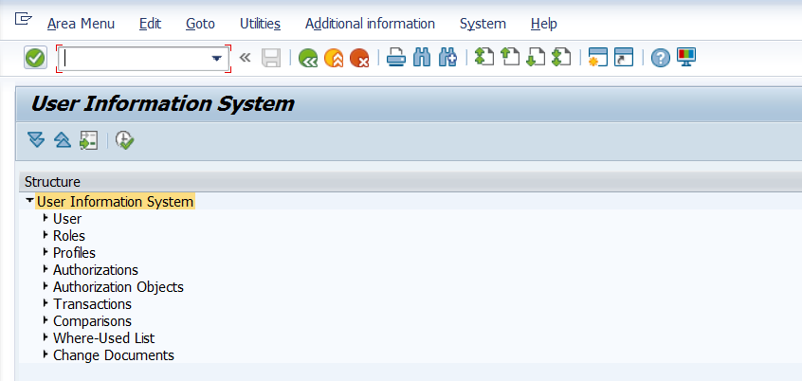
Note that changes for users, profiles, and authorizations are divided into two areas:
• Changes to authorizations: creating the user, changing, adding, or removing profiles
• changing header data: password changes, validity, user type, user group, account number, lock status
You can select both field to obtain all information. In this case, the left column shows the status before the change the right column the changed entry. You determine the changes for roles and role assignments using a separate interface.

Determine Documents for Users, Profiles, and Authorizations
1. Start the user information system (transaction SUIM). Expand the Change Documents node. Choose the Execute option next to For Users (or For Profiles or For Authorizations). Specify the user (or the profile, or the authorization) and other restricting values, and chooses Execute.
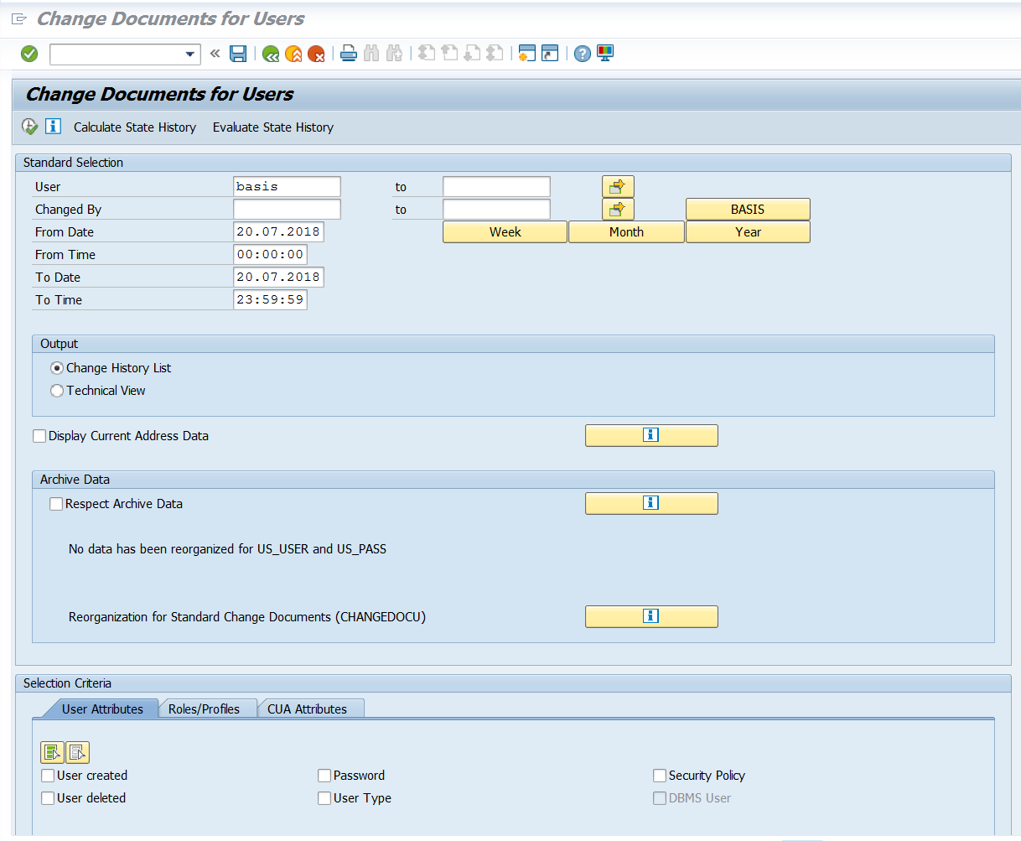

Determining Documents for Roles and Role Assignments
The interface for determining change documents for role assignment is a section of the interface to determine the change documents for roles.
1. Start the user information system (transaction SUIM). Expand the Change Documents node. Choose the Execute option next to For Roles (or For Role Assignments). Enter the required details and then choose Execute.
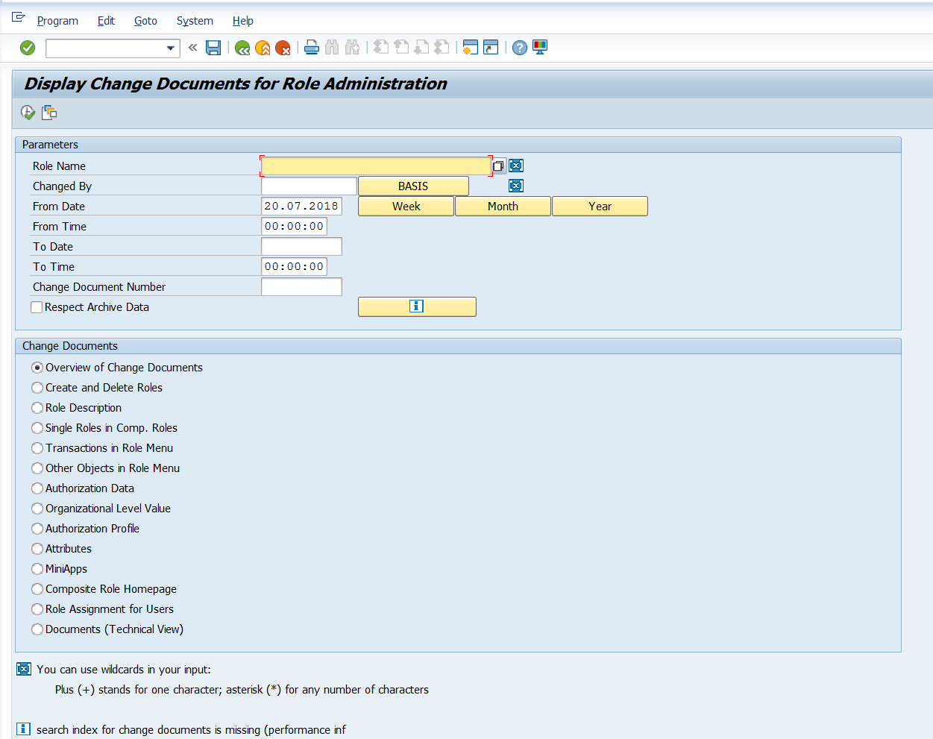
You can select an individual role or a particular change document with the fields Name of the Role and Change Number of the Document. You can use the fields Changed By and To Date or To Time to further restrict the selection. You can use the button next to Change By to enter your user name in the input field.
You can also choose the following document types under Change Documents, where an additional input field is displayed at the end of the list for some document types:
• Overview of change documents
• Creating and deleting roles
• Role description
• Single roles in composite roles
• Transactions in the role menu
• Other objects in the role menu
• Authorization data
• Org. level value
• Authorization profile
• Attributes
• Composite role home page
• User assignment

7) Transport Management System Overview (TMS)

Transport Management System is one of the key components in SAP system. TMS is used to control new requests, monitor changes like who has implemented the changes, defining and configuring system landscape in SAP environment.

TMS consists of 3 different Change and Transport System (CTS) components:

Change and Transport Organizer (CTO)

Transaction Code — SE01

This is used to manage, configure the changes in SAP repository and other objects. This provides you a central environment for development and configuration projects.

Transport Management System (TMS)

This is used to manage, control and copy development objects and for customization of settings across SAP systems in landscape using pre-defined transport routes configured with RFC Connections. This includes exporting the objects from one SAP system and importing to another target system.

Transport Tools

Tools are a part of SAP Kernel and are used to manage R3 trans and transport control program.

R3trans is known as SAP system transport which is used to transport the objects between different SAP systems. It is usually called for other transport control program, in particular from tp or by using SAP upgrade utilities.

Transport control program is used to support data and object transport between different systems running on different platforms and also on different database.

Configuring Transport Management

Transport management is one of the key components in SAP system landscape and is used to perform the following activities:

• Defining Transport Domain Controller

• configuring the SAP system landscape

• defining the Transport Routes among systems within the system Landscape

• distributing the configuration

Transport Domain Controller

This is used to manage all TMS configuration details. Any changes to configuration settings are distributed across all systems. To set up the Domain controller, use transaction code
— STMS

In case, the SAP system doesn’t have a Domain Controller, you will be prompted to create
a new one. Transport domain includes the following activities:

• User creation TMSADM

• RFC connection and request creation, TMSADM is used login to target system

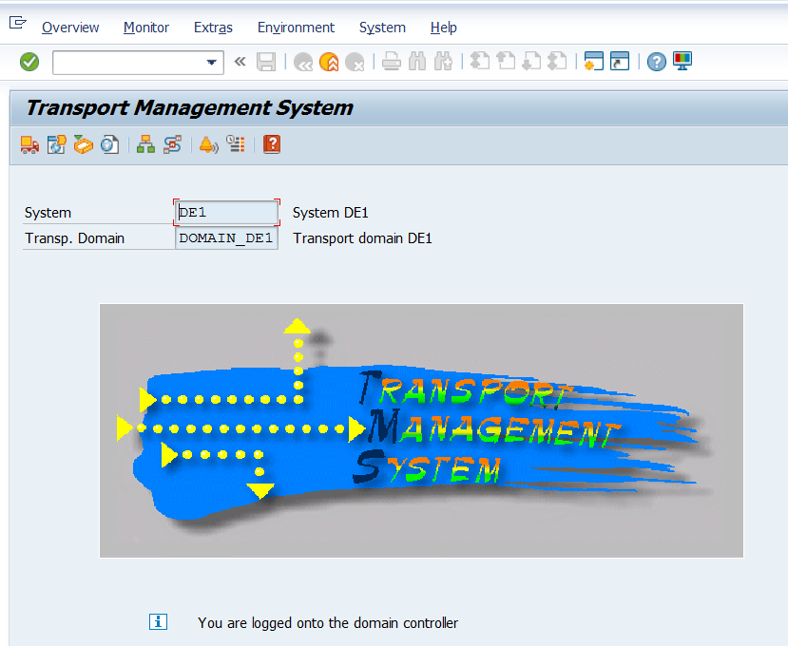

• DOMAIN.CFG file is created under usr/sap/trans/bin directory which stores TMS configuration and is used by systems and domains for checking existing configurations.

Follow these steps to add a system to Transport domain:

Step 1: Log on to the SAP system, that you want to add as a System, in client 000 and enter the transaction code — STMS. If system is not added, TMS will check configuration file DOMAIN.CFG and will prompt you to create one. Click on — Select the Proposal and Save. The system will remain in ‘Waiting’ status initially.

To complete the task-> login to the Domain Controller System -> Transaction STMS -> Go to Overview -> Systems.

You can now see that a new system is available. Go to SAP System -> Approve

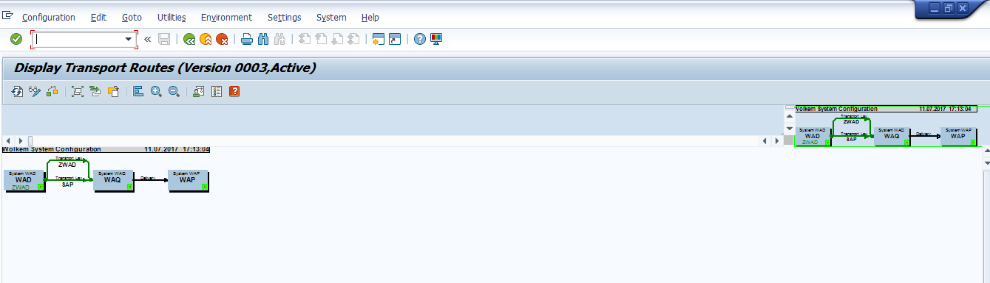

Transport routes are defined as routes that are defined by a SAP Administrator to transmit the changes between different SAP systems.

The following are the two types of transport routes:

• Consolidation (From DEV to QAS) — Transport Layers are used

• Delivery (From QAS to PRD) — Transport Layers not required

Transport Request

This contains a number of changes to be implemented in the development system. It consists of the types of changes, purpose, change category, target system and other details.

Transport request are named in a standard format like <SID>K<Number>

For example, in <SID>K<Number>:

• SID represents System ID

• K stands for fixed keyword/alphabet

• Number can be anything from a range starting with 900001

There are two type of request types that can be created in the SAP system:

Workbench Request

This request type contains the repository objects and cross-client customizing objects. Workbench requests are used to make changes in the ABAP workbench objects.

Customizing Request

This request type contains objects that belong to ‘client-specific’ customizing. These requests are created in system automatically when a user performs customizing setting and a target system is automatically assigned as per the transport layer.

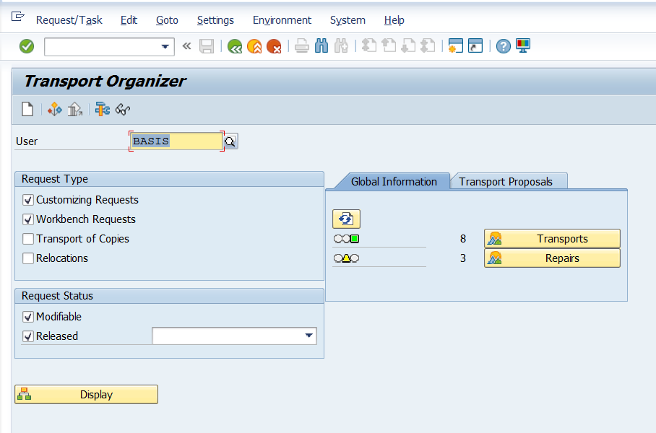

To create a Transport Request, use transaction code — SE01

A Transport Request can be created in the following two ways:

• Automatic — this way you can create or modify an object, or perform customizing settings. Here, the system displays the 'Dialog box' for creating a transport request or mention name of an already created request, if available.

• Manual — this way you can create the transport request from the Transport
Organizer, and then enter required attributes and insert objects.

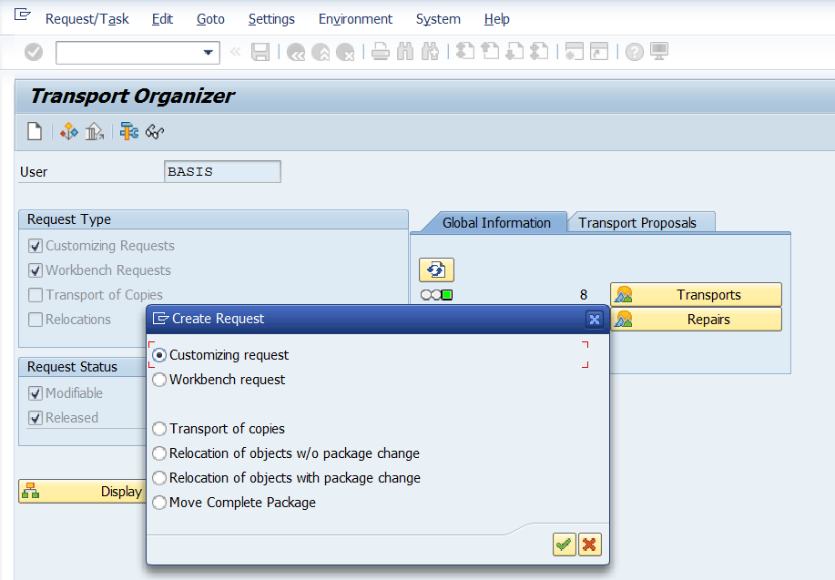

SAP Basis

Import / Export of Objects

Once transport request is completed in the source system, you have to export the request from the source system and import it to the target system. To perform the import, you have to select an import queue.

Transaction STMS -> Import or you can go to Overviews tab at the top -> Imports

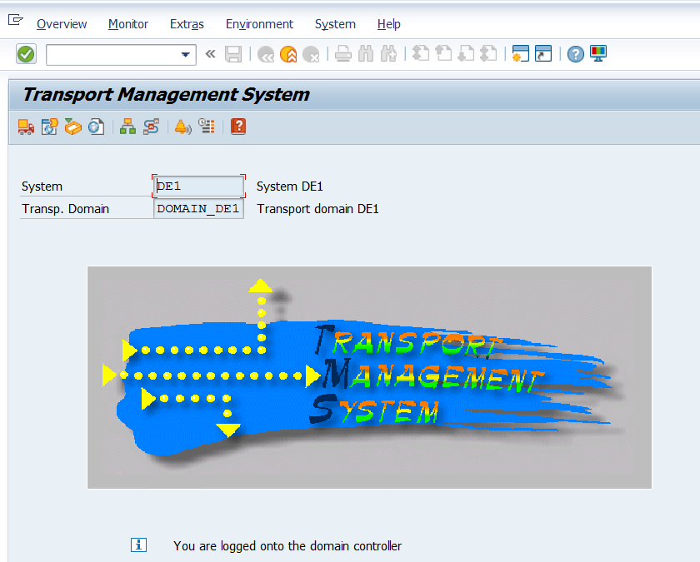

You can see a list of systems in the current domain, description and a number of requests available in Import Queue and the status.

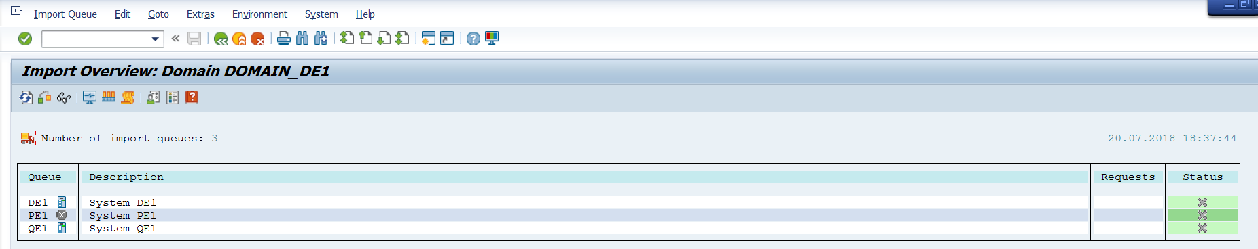

Import a Queue

This list contains Transport Requests in the common directory. These requests are ready to be imported to the target system.

Transport Request Logs

You can also check the logs once the transport request is completed. To check the logs, use transaction code — SE01 -> GoTo -> Transport Logs

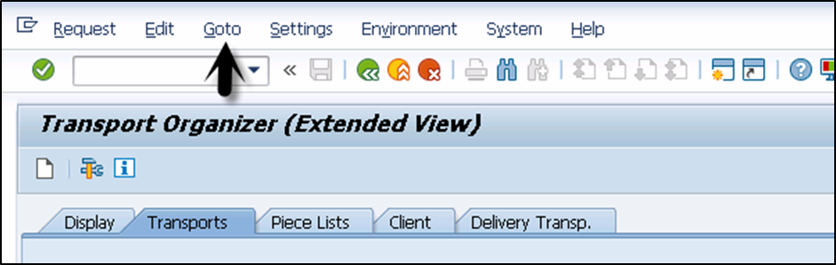

There are two types of logs available in Transport Management System:

Transport Logs

It keeps track of the transport log files that have been moved in a Transport Request.

Action Log

It includes the details of all the actions that have been performed in a Transport Request. Actions such as exports, import, etc.

One of the important functions provided by the logs are the following return codes:

• 0 — this value represents that export was successful.

• 4 — this value represents that a warning was issued and the objects were transported successfully.

• 8 — this value represents that a warning was issued and at least one object could not be transported.

• 12 or higher — this value represents an error in transport request and it is generally not caused by the objects in Transport Request. This probably occurs because of system failure.

8) How to Start SAP Router:
Go to RUN
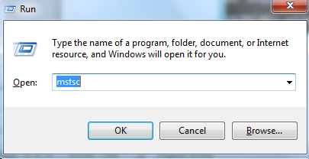
Type “mstsc” in runclick on Ok
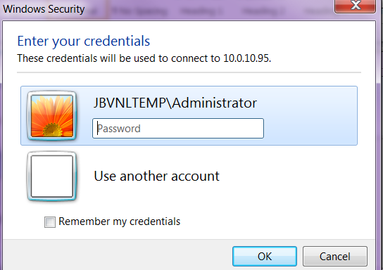
Provide login credentials and click on Ok.

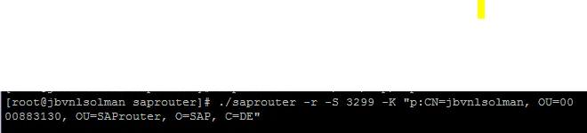
Open run and type “CMD” click on ok.
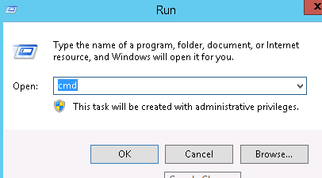

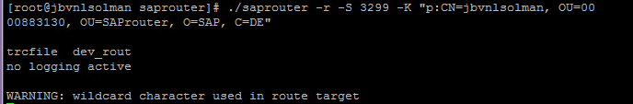
Provide above command to start Router.

8) DMS SERVER 10.0.10.38
- Execute CSADMIN. Select the Content repository you created

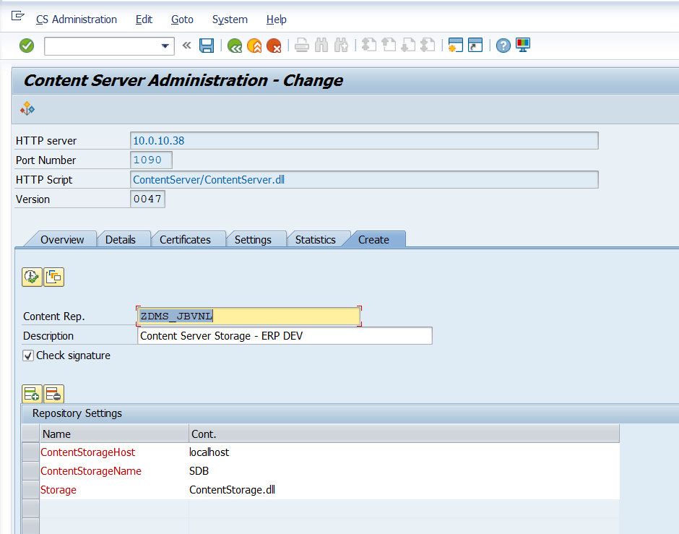
- Execute report RSHTTP80 to check whether data is saved.
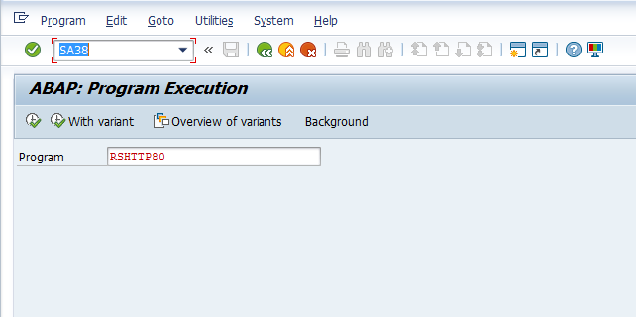
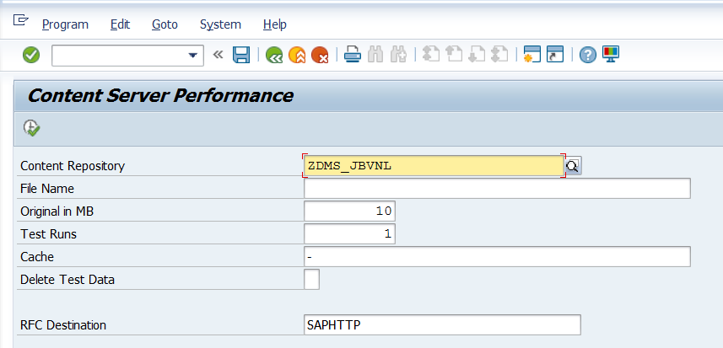

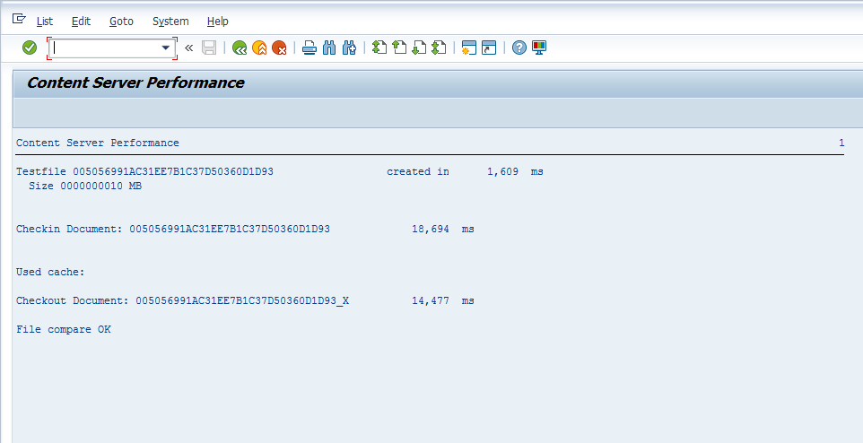
Status to check DMS SERVER
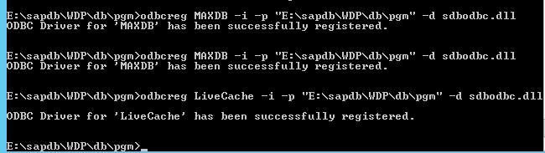
For ODBC ERROR you have run above command in DMS Server.

11) Database administration:
Backup Catalog Log
DB02
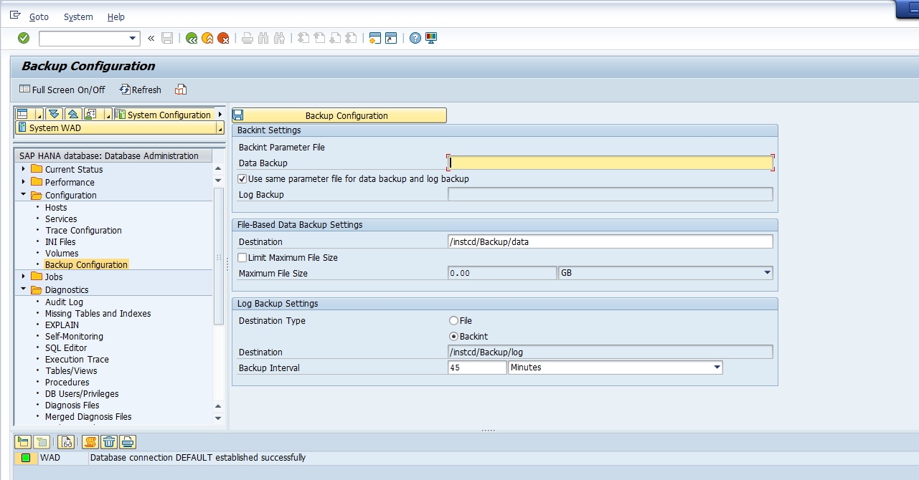
Backup Configuration: provide required Inputs as per requirement like Destination Type
DB02

10) DB13: DBA Planning Calendar
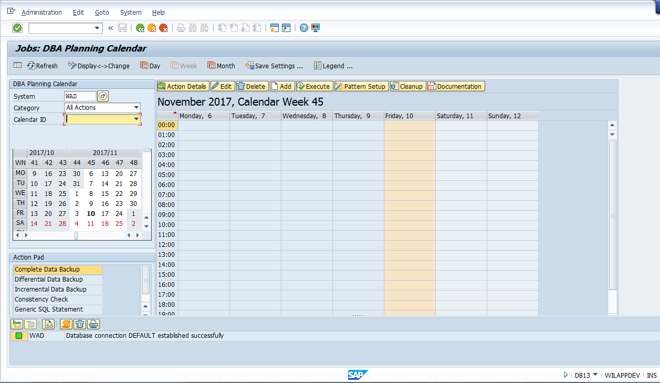
To schedule Backup

11) DB12: Backup Catalog is to collects and presents information that is necessary to monitor database backups. It is an important source of information for the database administrator who has the task of supervising the execution of a defined backup strategy.
On the initial screen of the monitor, it shows overview of important information related to SAP database backups.
• The last successful backups for the SAP, master and msdb databases and transaction logs.
• The last SAP database size and duration of the backup job.
• Whether the SQL Server Agent is started or not.
• The amount of log space allocated and how much is still free.
• The Recovery interval, which specifies the maximum time that SQL Server should spend recovering after a database startup.

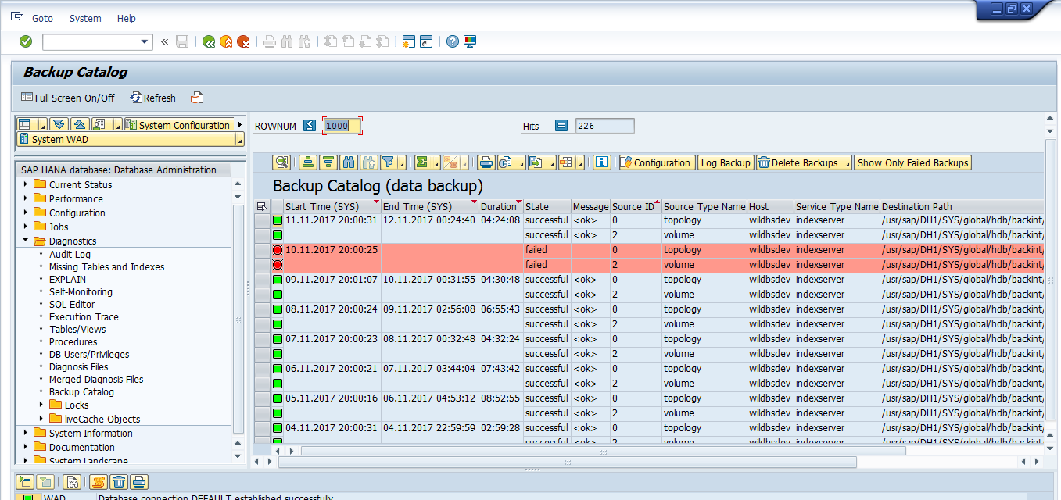
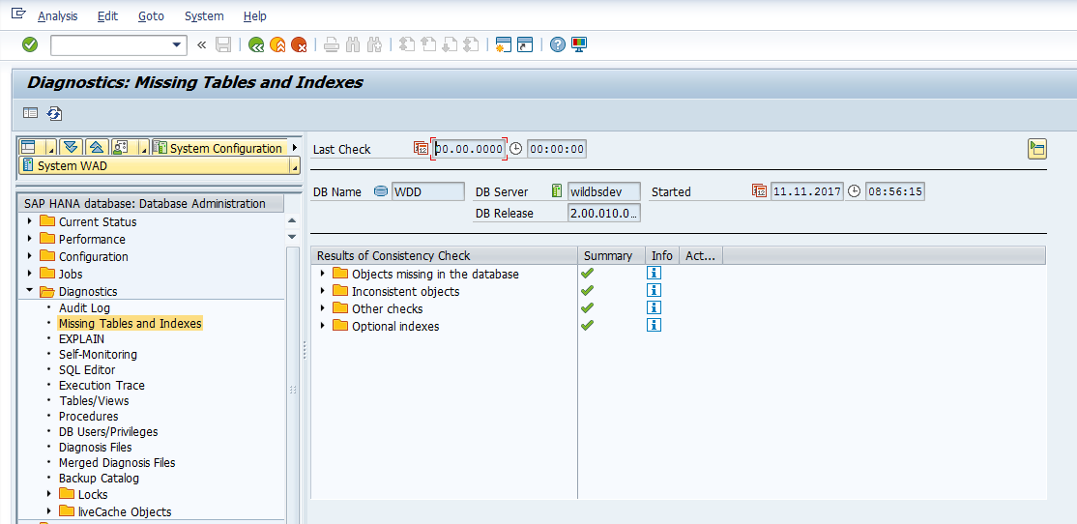
Check Missing Table Indexes:
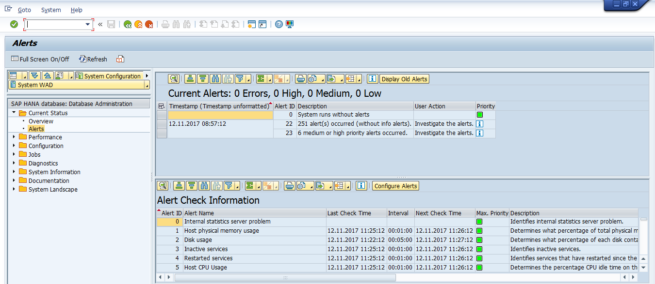
Check DB alerts if Any

12) SAP Note:
Snote: t-code apply sap Note

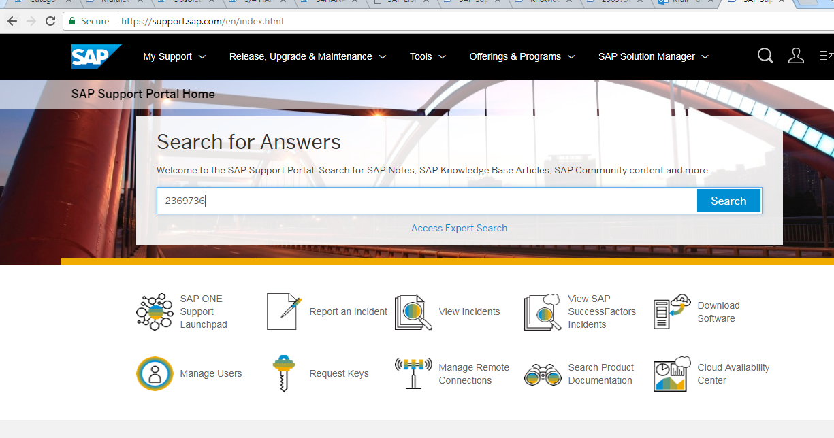
View incident
Report an Incident
Open remote connection for SAP
Download licence
Download
Software

Goto tcode snotemenuGo To—Download SAP noteprovide not number which you want to apply
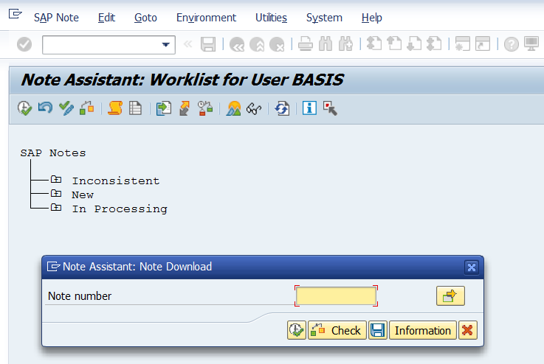
Then go to MenuSAP Note—Implement SAP Note.

13. Slicense: to apply SAP license.
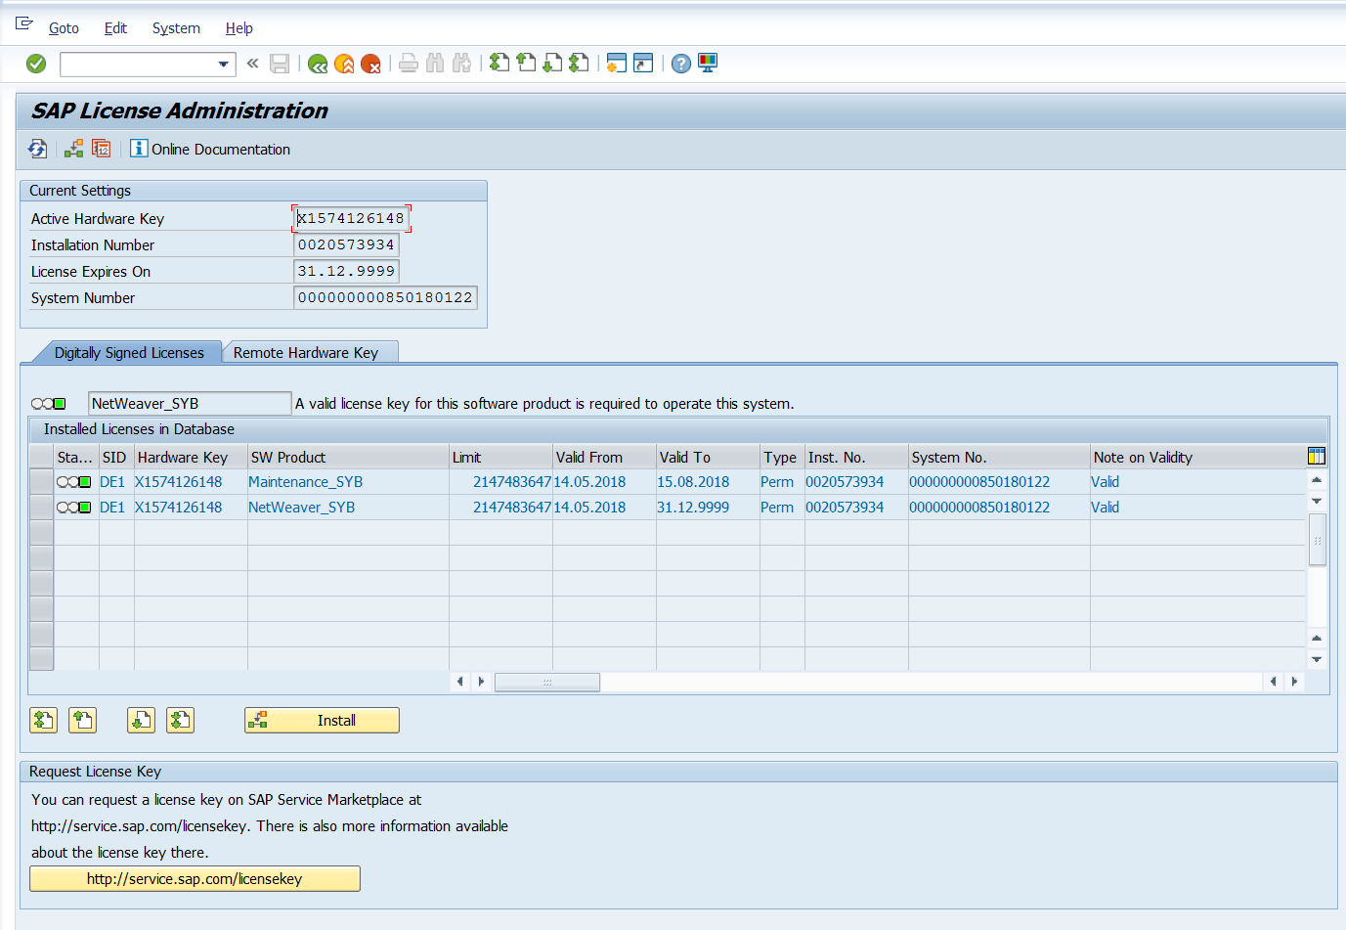
Hardware id for license key
Permanent KEY
Maintenance KEY

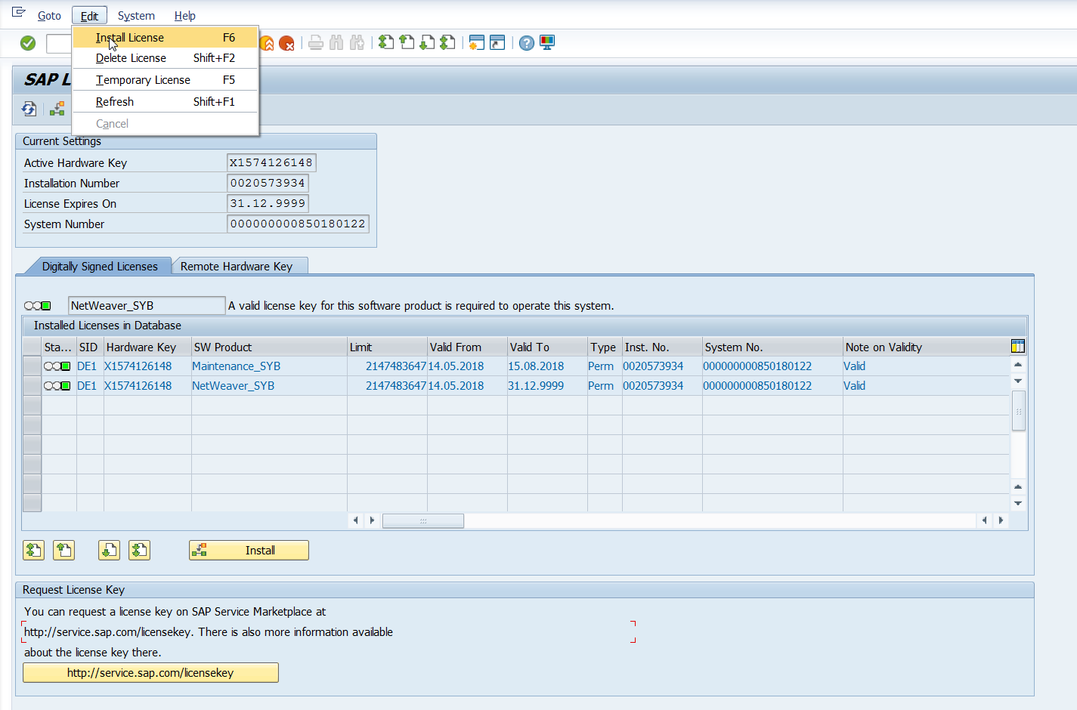
To Install The License Go-service Market Placeclick On Request Keyenter S-User id Credentialsbrowse system which you want to renew licenceverify DetailsGenerate Maintenance Licensedownload license fileopen GUIexecute “slicense” tcode Menuclick on EDITclick on Installbrowse file location click on ok.

What are Support Pack Stack version numbers?
Support Package Stacks have a release number, and a Stack number, Example, SAP NetWeaver '04 Support Package Stack 11.
Each software component has a separate sequence of Support Packages. The following list contains the technical names of a number of components and the notation for their Support Packages:
- COP (Component Package):
- S4core (S4core Support Package): SAPK<rel><no>
- SAP_BASIS (Basis Support Package): SAPKB<rel><no>
- SAP_ABA (Application Basis SP): SAPKA<rel><no>
- SAP_HR (SAP HR Support Package): SAPKE<rel><no>
- SAP_SCM (SCM Support Package): SAPKY<rel><no>
- SAP_BW (BW Support Package): SAPKW<rel><no>
- SAP_CRM (CRM Support Package): SAPKU<rel><no>

Pre-requisites for Support Package implementation:
- Support packages should be always applied in client 000.
- The user to be used for the support package implementation must have authorizations equivalent to DDIC or SAP*
- Call the transaction SPAM and see if any previous Support Package import is incomplete. You can proceed ahead unless the previous support package import is successful.
- Ensure that there is enough space in the transport directory. The transport directory is located at /usr/sap/trans

14) Steps to Upgrade the Support Package:

Step 1: Download Support Packs
Support Packages are available in SAP Support Portal, under support.sap.com/patches.
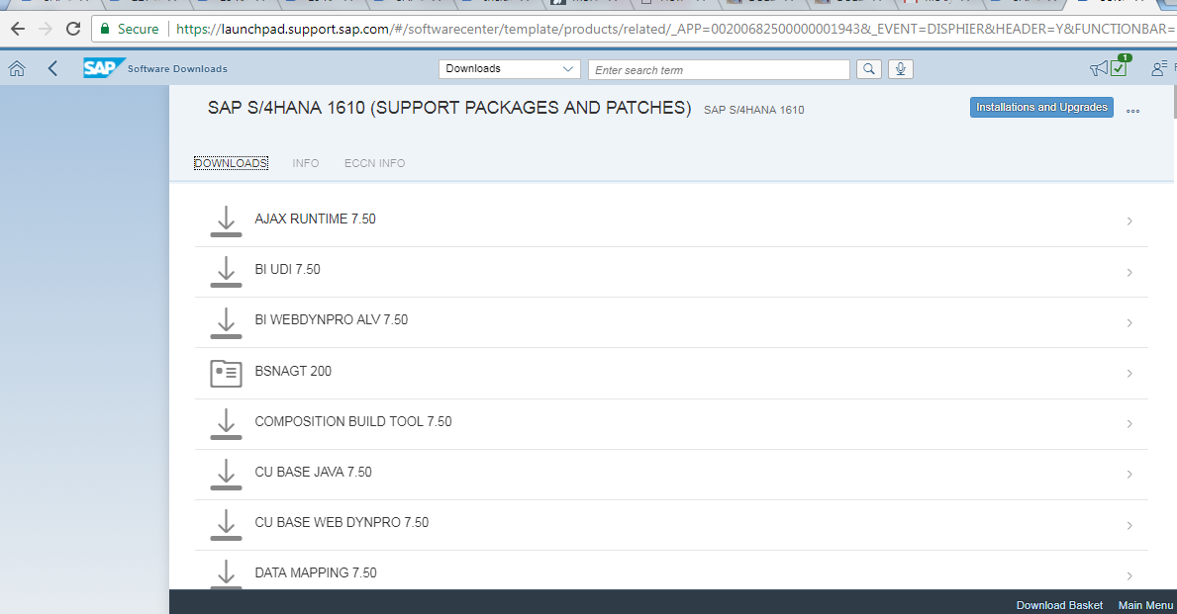
Step 2: Loading Support Packages:
To load support packages we have two options:-
- From Application Server
- From Front End
From Application Server
- Download the support packages from service marketplace and save them at OS level in directory /usr/sap/trans.
- Uncompress these files using sapcar executable
sapcar –xvf <support package name>

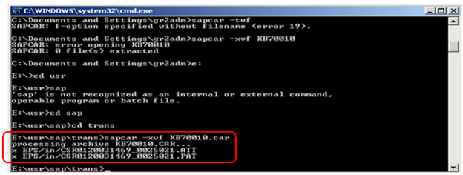
After uncompressing the support packages at OS level the .PAT and .ATT files are stored in /usr/sap/trans/EPS/in directory.
Next, load the Support Packages into SAP system by choosing Support Package -->Load Package --> From Application Server
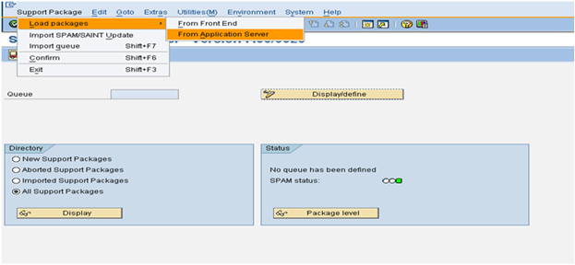
From Front End
Choose Support Package --> Load Packages --> From Front End
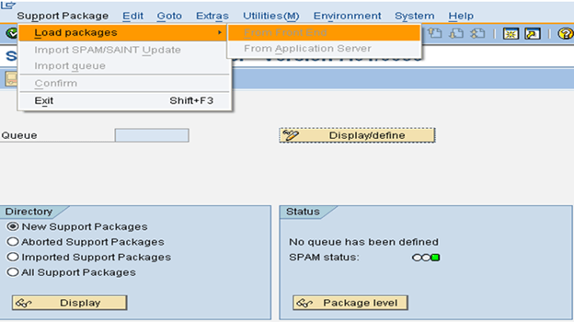
Step 3: SPAM/SAINT Update:
A SPAM/SAINT Update contains updates and improvements to Support Package Manager (SPAM) and Add-On Installation Tool (SAINT). There is always one SPAM update for each release. SPAM/SAINT update is mandatory before any support package upgrade.
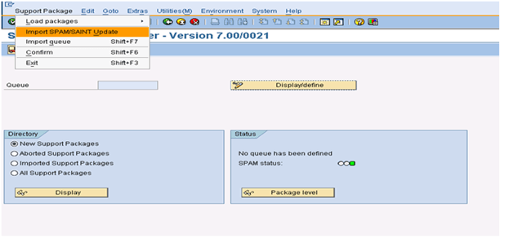
Step 4: Defining Queue
Queue contains the Support Packages available for the different SAP Components installed in your system. This Queue information is derived from the support pack uploaded in Step 2.
1.On the initial screen in Support Package Manager, choose Display/Define.
2.A list of installed software components (for example, SAP_BASIS, SAP_HR, SAP_BW) is displayed.
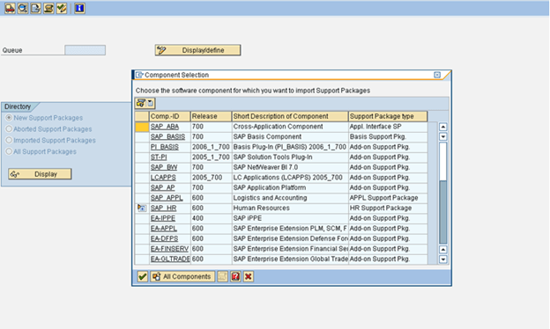
3. Once you select the required component, the current queue appears. This queue contains the Support Packages available for the selected component in your system. If you want to define the queue for another software component, choose Other Component. If the displayed queue meets your requirements, you can confirm it by choosing Confirm Queue
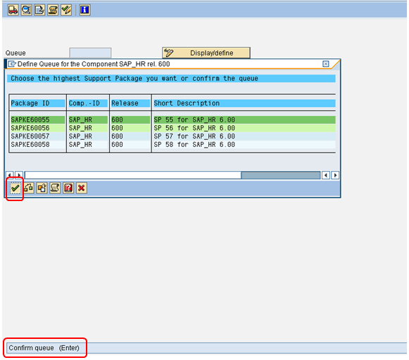
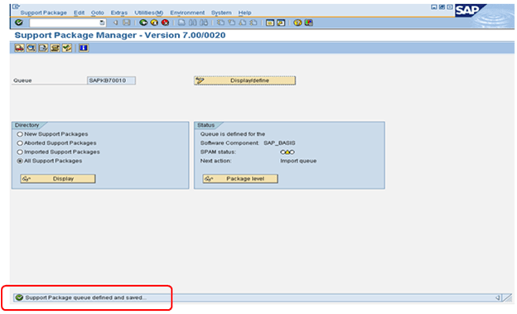
Step 5: Importing Queue.
Once you a define a Queue (Step 4) while selecting a particular component (for which we want to upgrade support pack), we need to do 'Import queue' to start importing/applying that particular selected support pack (as per the standard SAP process).
Choose Support Package --> Import Queue
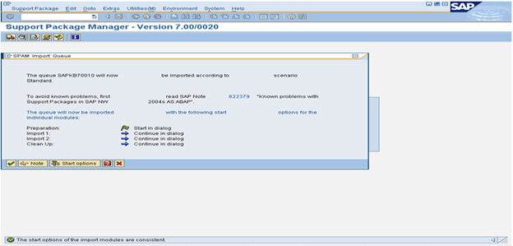
To become familiar with known problems and issues, always read the note mentioned in above screenshot.
The support package import has been started
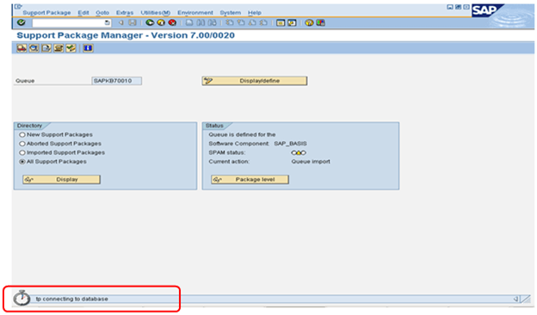
Step 6: Confirming Queue:
Confirm that the queue has been imported successfully into your system. This allows you to import Support Packages in the future. You will not be able to import Support Packages further, if you do not confirm the queue.
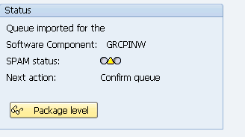
Once Queue has been imported, SPAM status becomes YELLOW
Confirm successful import of the Support Packages into your system by choosing Support Package à Confirm.
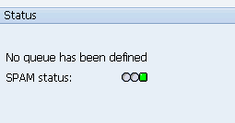

Checking Logs

- IMPORT LOG: It displays logs for Support Package Manager Phases that are used by transport control program tp(transport control program).
Go to-->Import log-->Queue
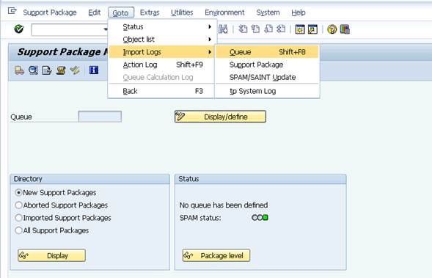
- ACTION LOG: It contains information about the actions that take place during the individual phases (while importing the current queue).
It also includes information about the point at which a phase was stopped, as well as detailed error information.
To display the logs for the current queue Go to-->Action log
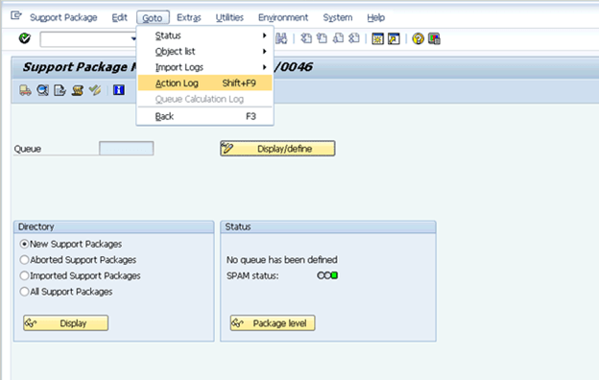
While the support packages are being imported, logs are made into the tmp directory (path: usr/sap/trans/tmp)
- Once the import process is completed logs can be viewed from the log directory (path: usr/sap/trans/log)

Se16 Table content
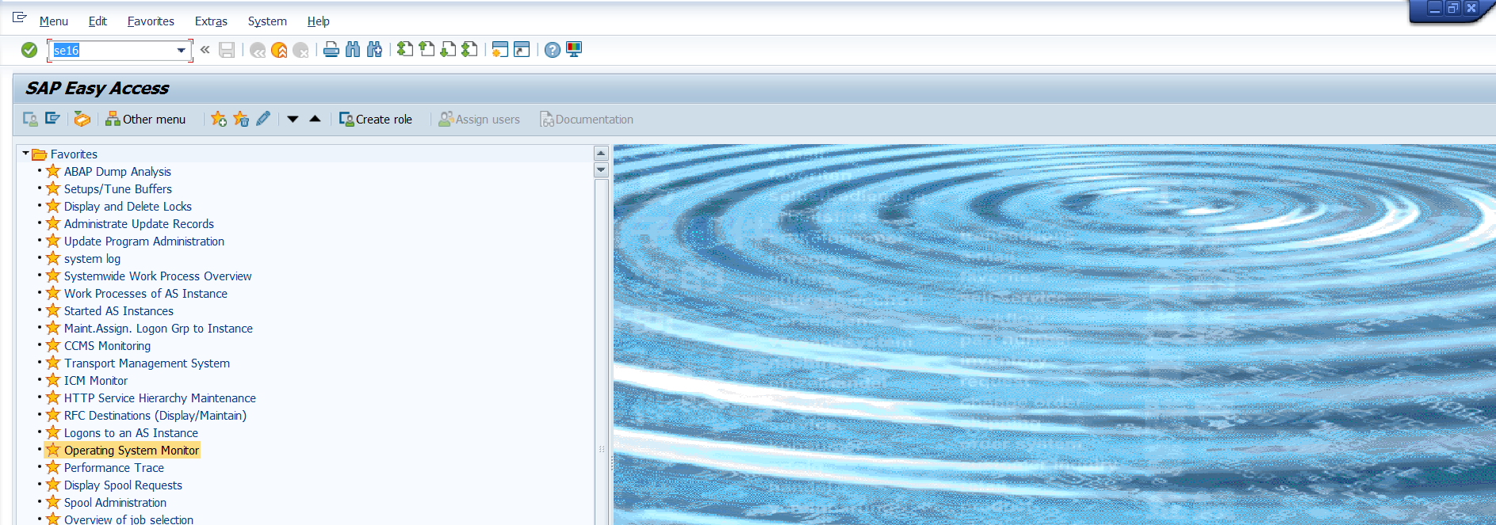

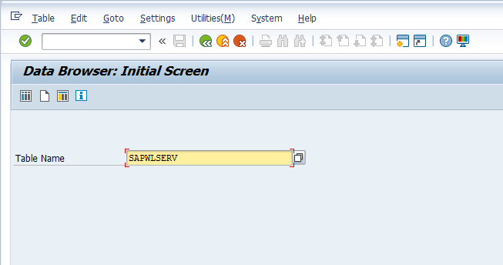
Table Name SAPWLSERV
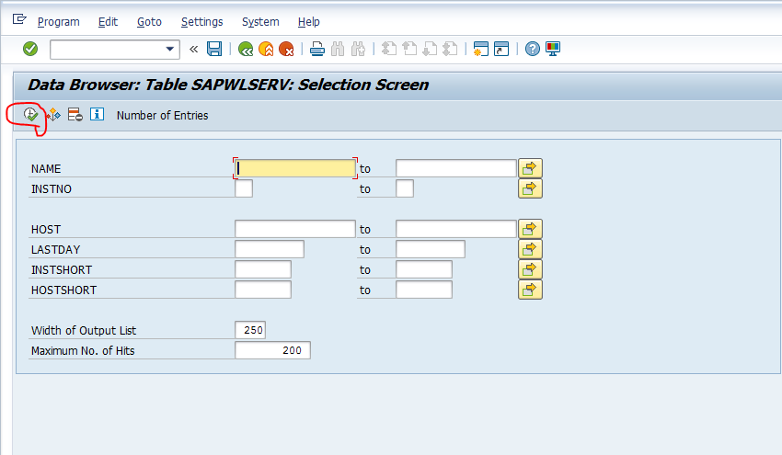
Execute
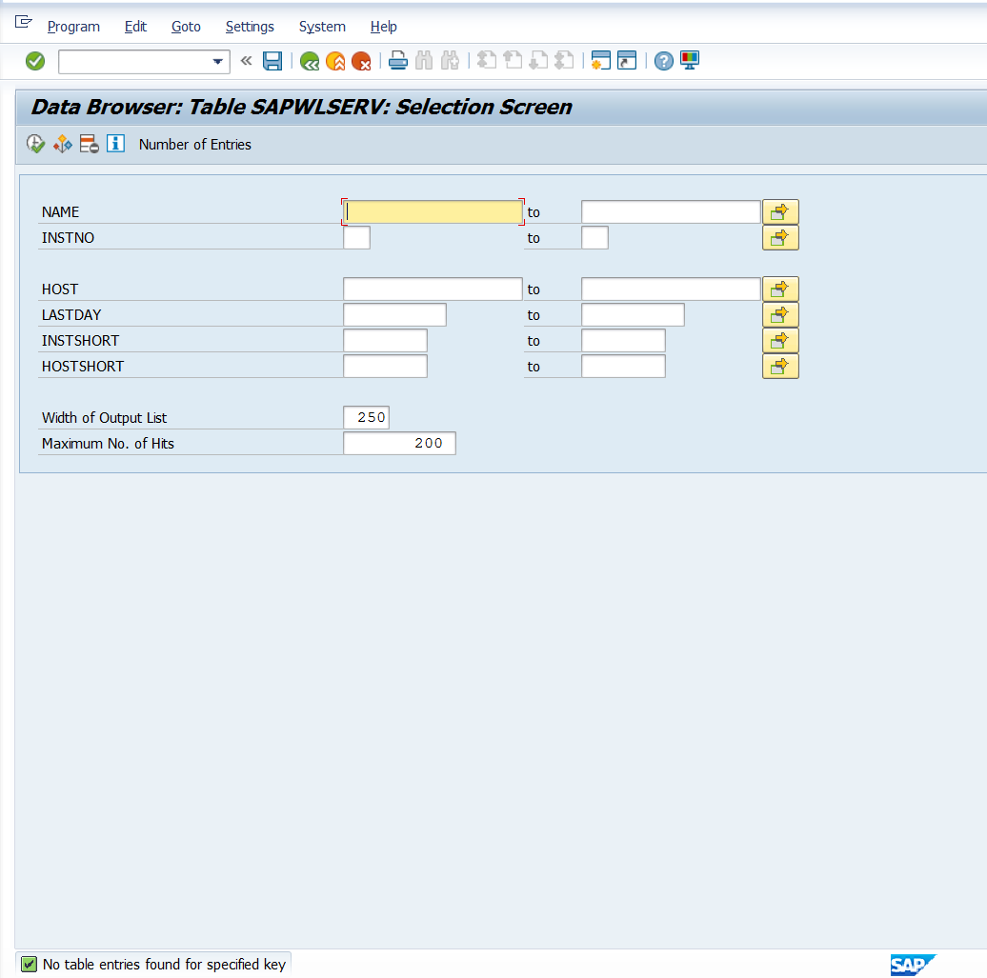
You will get details: (this is for view only don’t change anything here)

